**Q1. Install Virtual box and making Ubuntu And Window Virtual Machine.**

**Ubuntu:**

**Step-1**: Download VirtualBox for Windows and install it on your computer

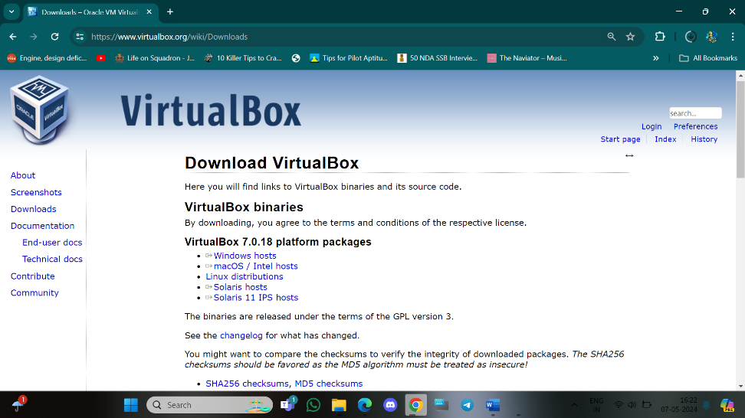

<https://www.virtualbox.org/wiki/Downloads>

**Step-2**: Download the Ubuntu ISO file you want to install from the Ubuntu download page.



Note: The current version of Ubuntu only works on 64-bit machines.

**Step-3:** Open VirtualBox and select New in the top taskbar.



**Step-4:** Give your VM a name, choose Linux as the Type, then choose Ubuntu as the Version and select Next.



**Step-5:** Choose how much RAM you want to assign to the virtual machine and select Next. The recommended minimum is 1024 MB.



**Step-6:** Choose Create a virtual hard disk now and select Create.

**Step-7:** Choose VDI (VirtualBox Disk Image) and select Next.



**Note on (VDI):** Normally, Oracle VM VirtualBox uses its own container format for guest hard disks. This is called a Virtual Disk Image (VDI) file. This format is used when you create a new virtual machine with a new disk.

S**tep-8**: Choose Dynamically allocated or Fixed size for the storage type and select Next.



Tip: A fixed size disk performs better because the virtual machine doesn’t have to increase the file size as you install software.

**Step-9:**  Choose how much space you wish to set aside for Ubuntu and select Create.

**Note:**  The amount of space you allocate for your virtual machine determines how much room you must install applications, so set aside a sample amount.

**Step-10:** The name of your virtual machine will now appear on the left side of the VirtualBox manager. Select Start in the toolbar to launch your VM.



**Step-11:** This is the point where you need to choose the Ubuntu ISO file you downloaded earlier. If the VM doesn't automatically detect it, select the folder next to the Empty field.



**Step-12:** Select Add in the window that pops up.



**Step-13:** Choose your Ubuntu disk image and select Open.



**Step-14**: - Select Choose



**Step-15:** Select Start.



**Step-16:**  Your VM will now boot into a live version of Ubuntu. Choose your language and

select Install Ubuntu

u. 

**Step-17:** Choose your keyboard layout and select Continue.



**Step-18:** Choose Normal installation or Minimal installation, then select Continue.

**Step-19:** Choose Erase disk and install Ubuntu and select Install Now, then select Continue to ignore the warning.

Note: This step will not erase your computer’s physical hard drive; it only applies to the virtual machine.



**Step-20**: - Choose your time zone on the map, then select Continue.

**Step-21**: - Set up your user account and select Continue.



**Step-22**: - Select Restart Now.



**Step-23**: - After restarting your VM and booting into Ubuntu, you may notice that the desktop doesn’t scale correctly if you choose to view it in full-screen mode. You can fix this problem by selecting the VBox_Gas icon to install VirtualBox Guest Additions.

**Output:**



**Windows:**

Similarly, Follow the same steps above to Build Windows Virtual Machine.

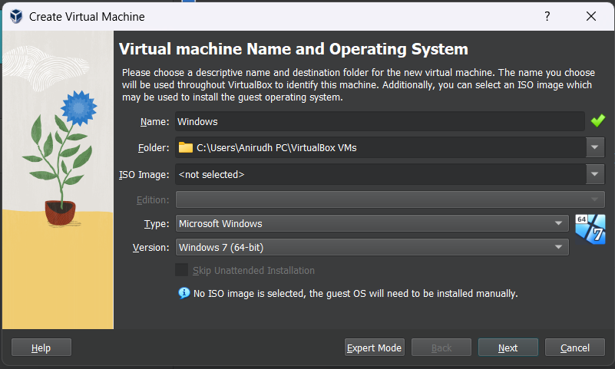

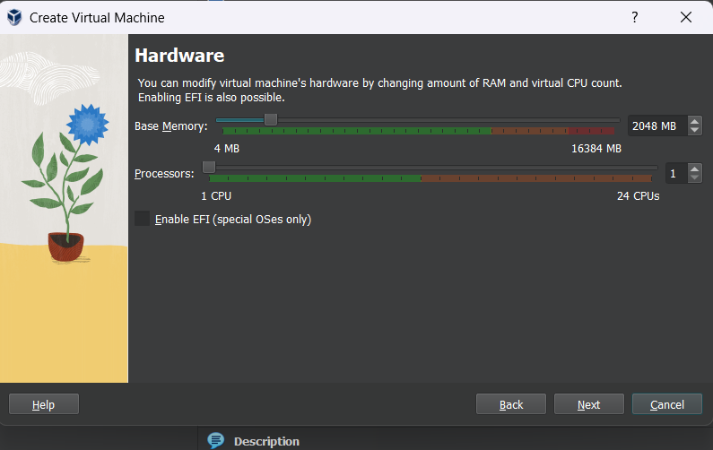

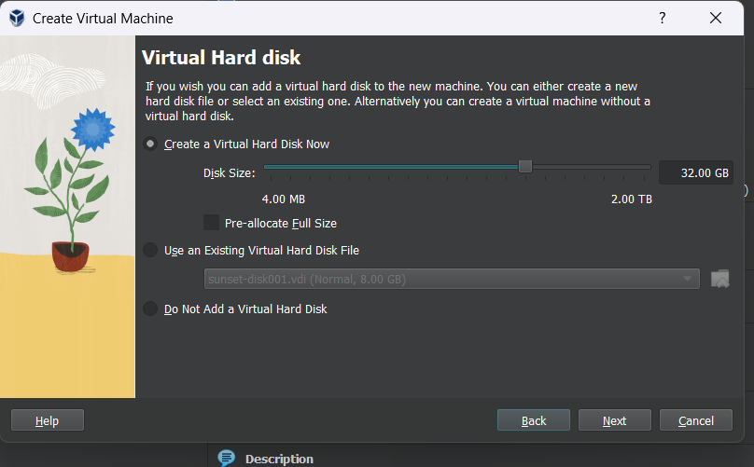

**Output:**

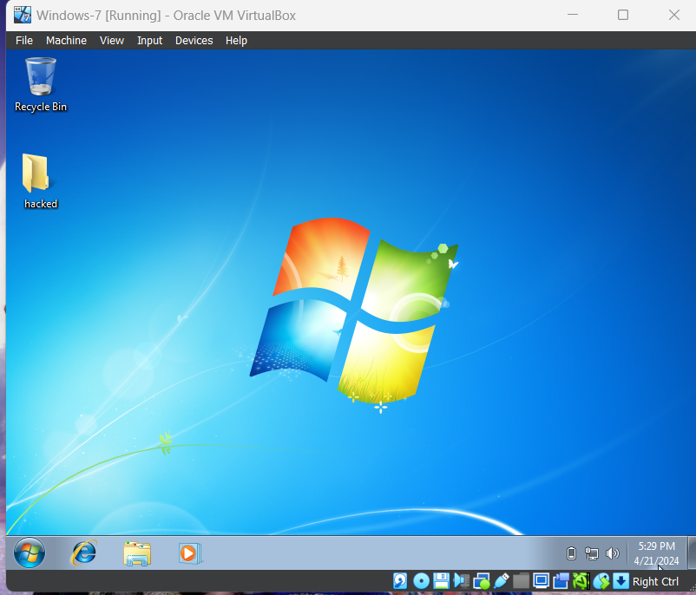

**Q2) Create a Windows Virtual Machine in Microsoft Azure**

**Step-1:** Sign in to your Microsoft Azure account.

**Step-2:** Go To Virtual machine, and click on “Create” to create a window virtual machine.

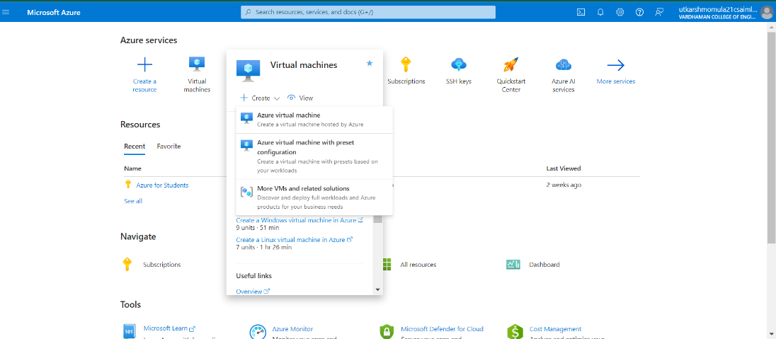

**Step-3:** Fill the details in that window by creating a “Resource Group”, Zone: Asia, Image: window, Select the disk storage and so on. After that click on “Create + Review”. And Finally click on “Create”

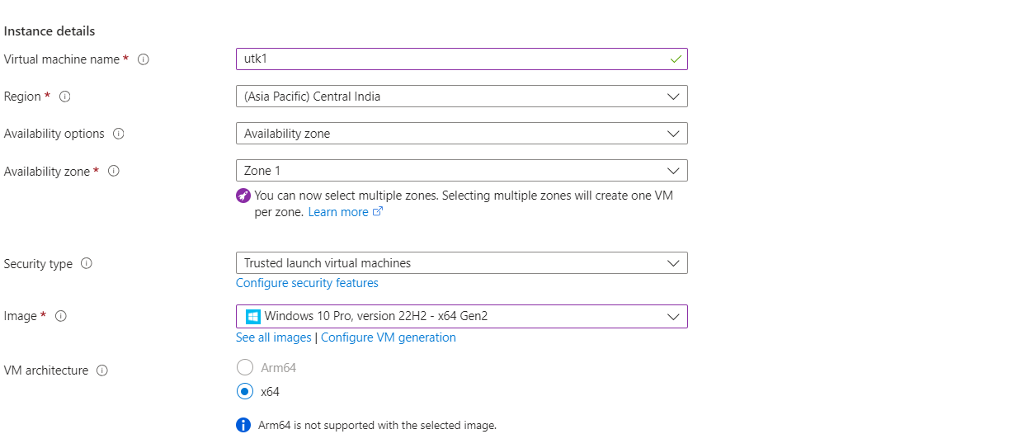

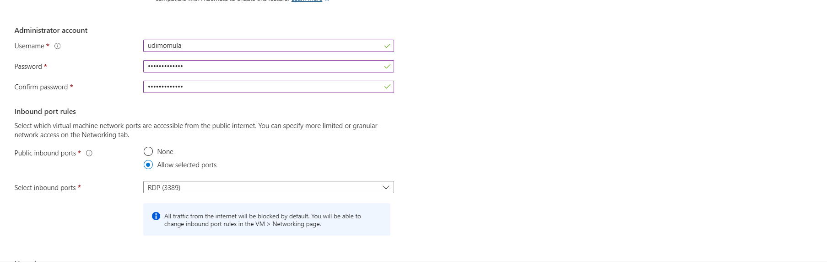

**Step-4:** Firstly, copy the public IP Address of that created virtual machine.

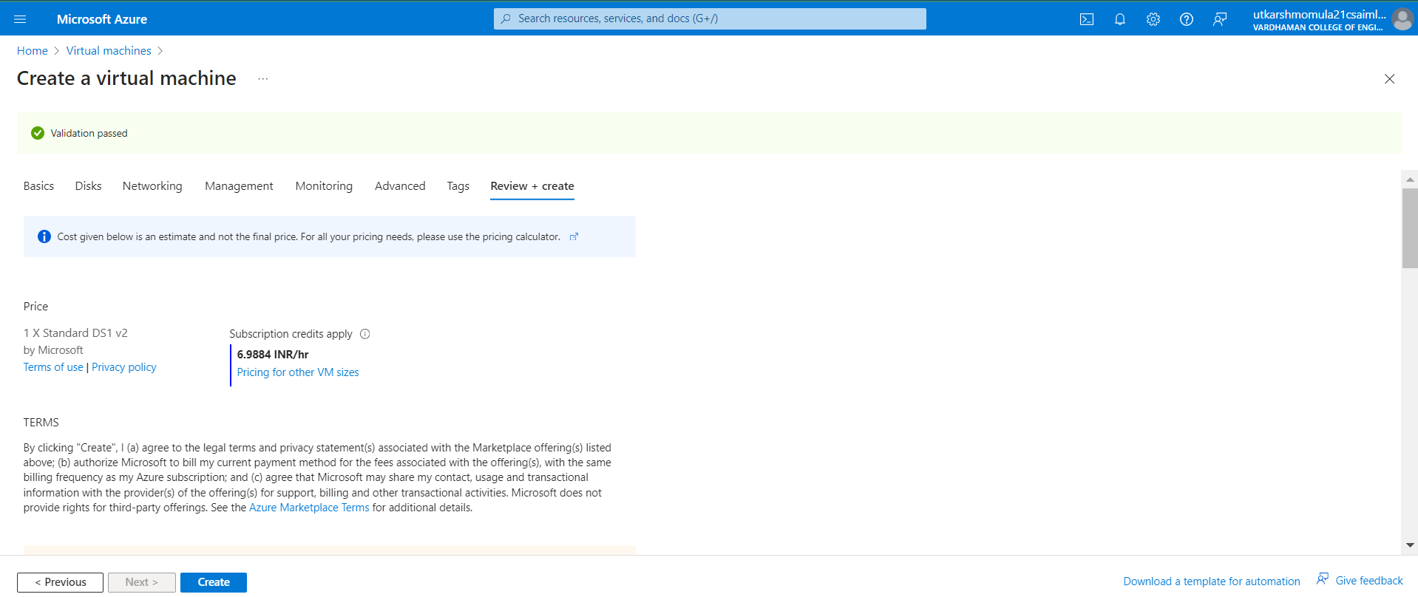

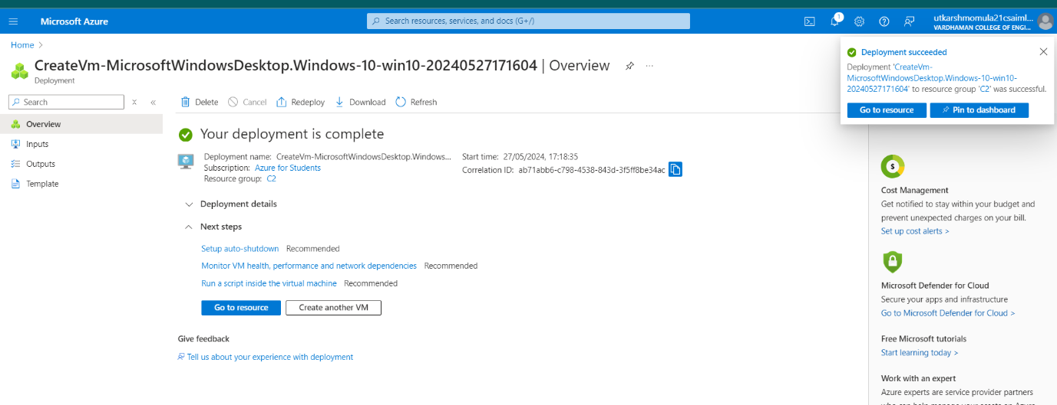

**Step-6:** By using that copied IP Address open the window virtual machine through remote desktop connection.

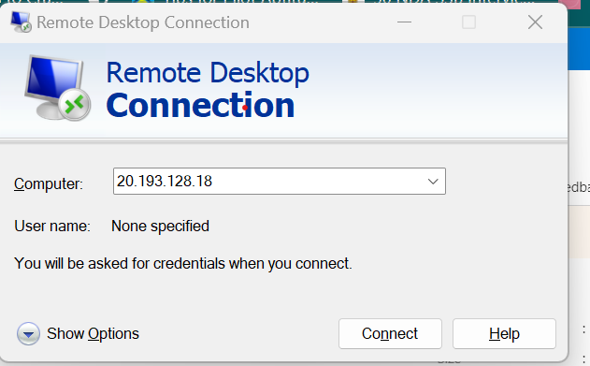

**Output:**

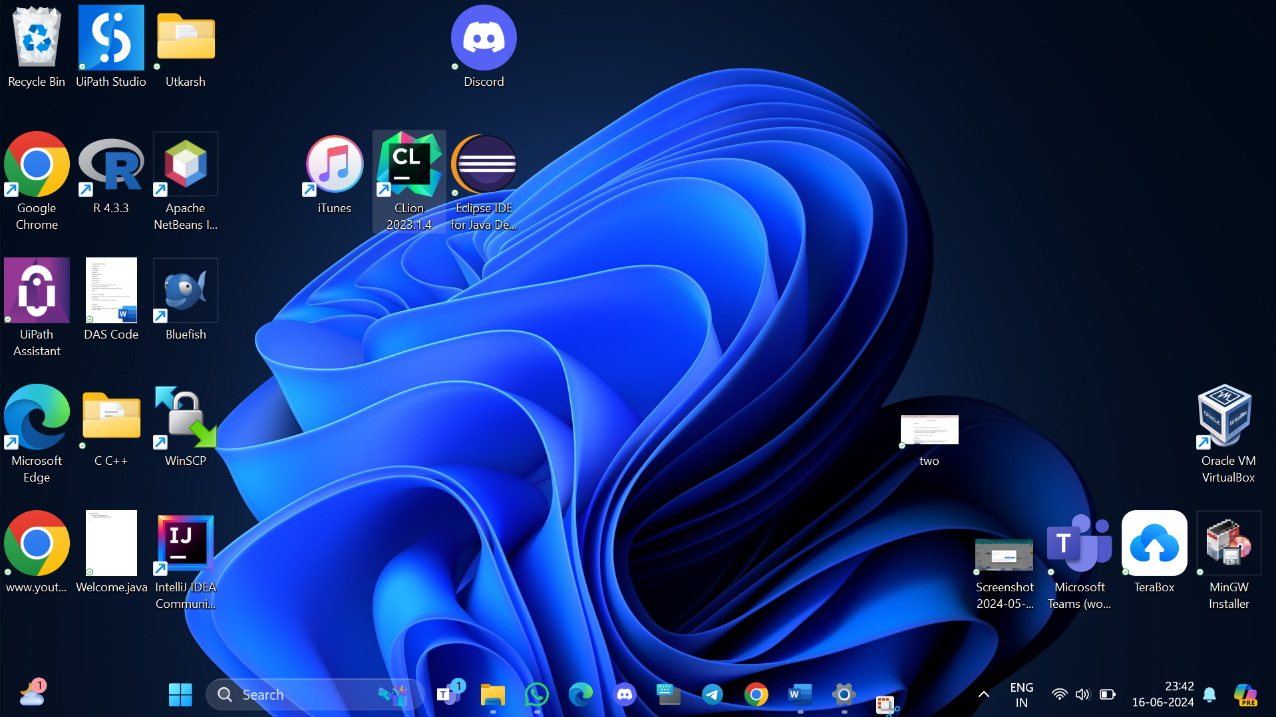

**Q3) Create a Ubuntu Virtual Machine in Microsoft Azure**

**Step-1:** Sign in to your Microsoft Azure account.

**Step-2:** Go To Virtual machine, and click on “Create” to create a window virtual machine.

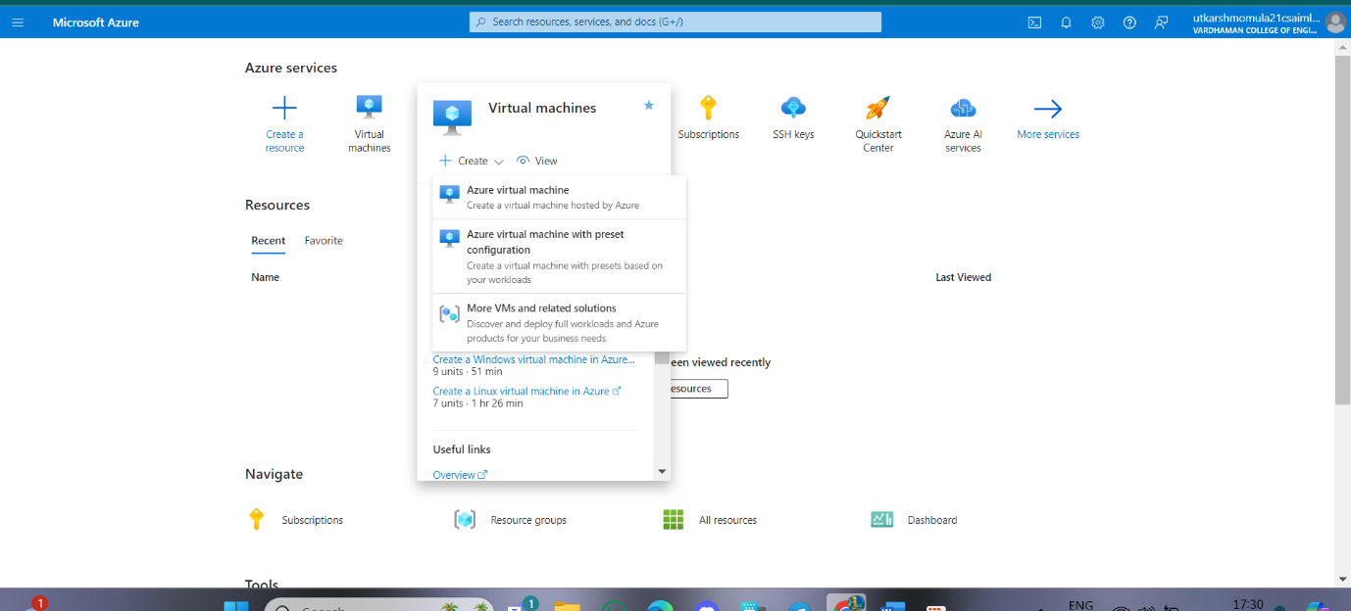

**Step-3:** Fill the details in that ubuntu by creating a “Resource Group”, Zone: Asia, Image: ubuntu, select “SSH”, Select the disk storage and so on. After that click on “Create + Review” and click on “Create” then download key and open resource group.

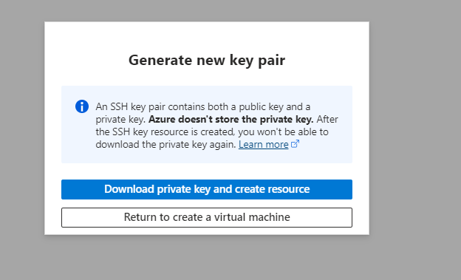

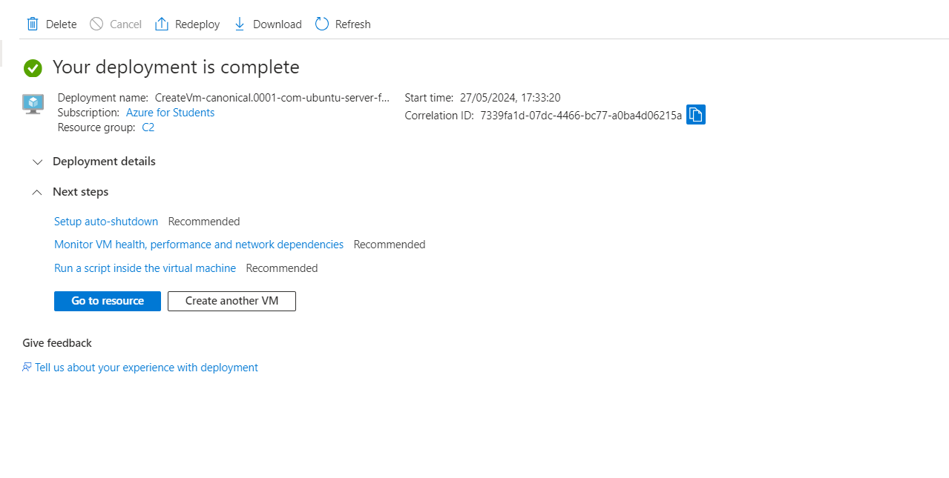

**Step-5:** Firstly, copy the public IP Address of that created virtual machine and after Deployment is over, Go to the remote desktop connection. 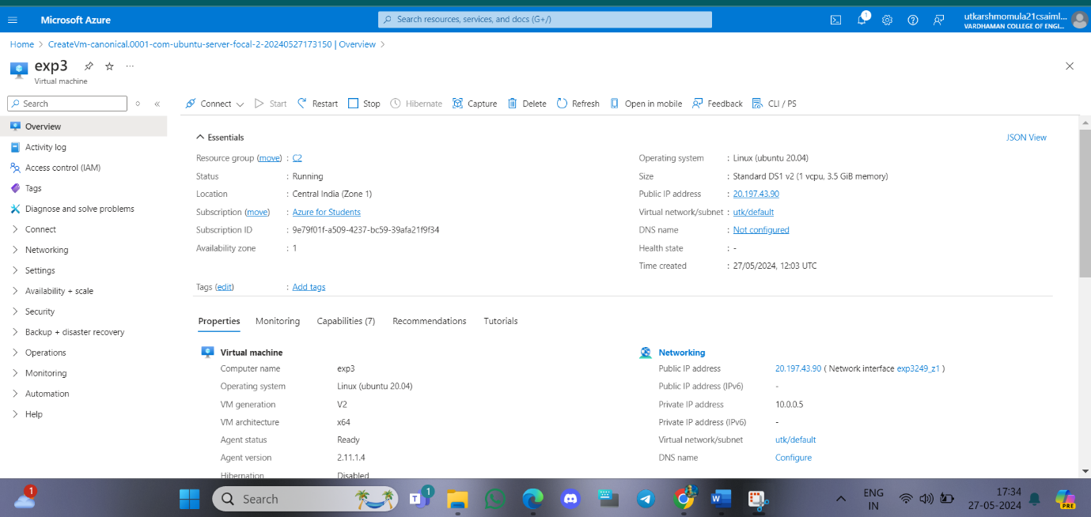

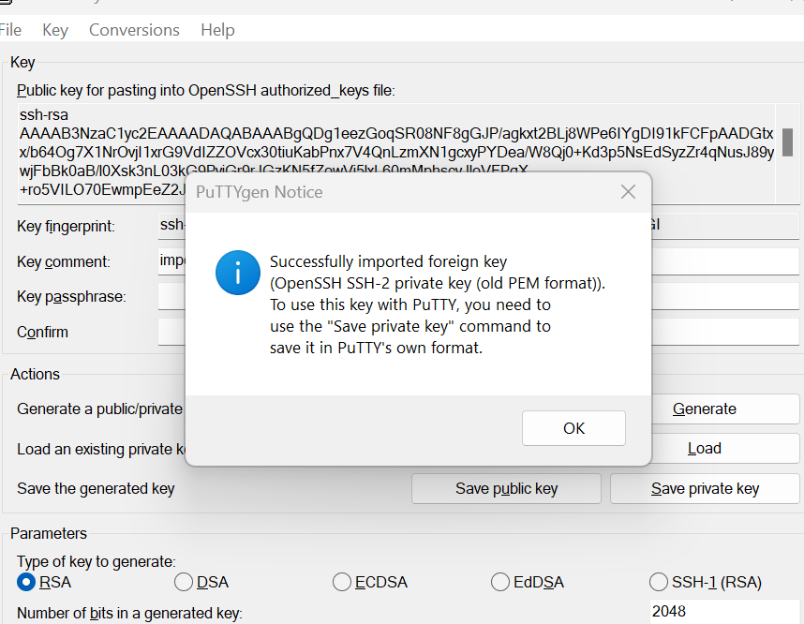

**Step-6:** Go to putty gen and click on load the key generator that you have downloaded.

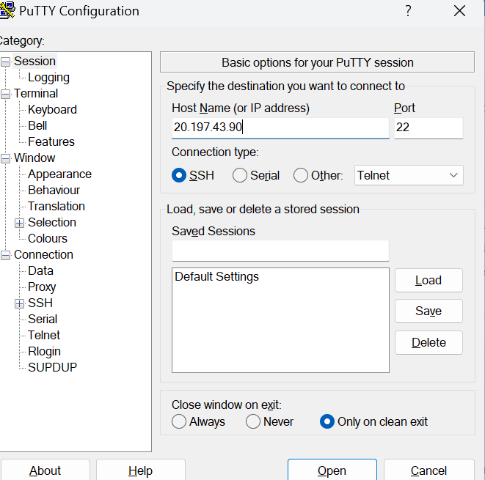

**Step-7:** In putty, put the Copied IP Adress into it, and then go to ssh->auth->credentials And the put the generated private key.

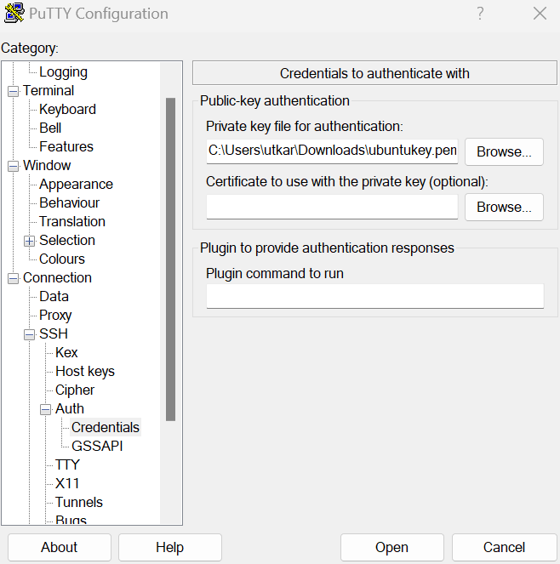

**Step-8:** A login page will be opened in that type your username and you will be into the ubuntu.

**Step-9:** After this delete its resource group and virtual machine.

**Output:**

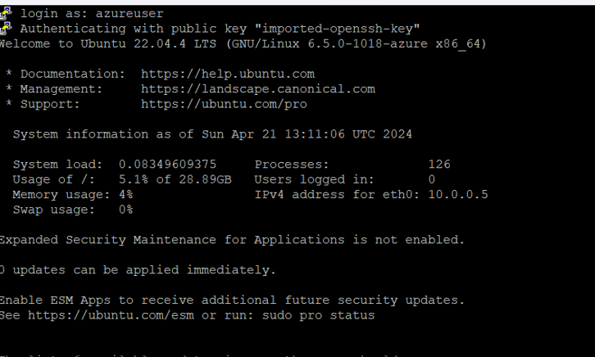

**Q4) Create a Virtual machine and do scale up in Azure.**

**Step-1: Create a virtual machine (ubuntu or windows).**

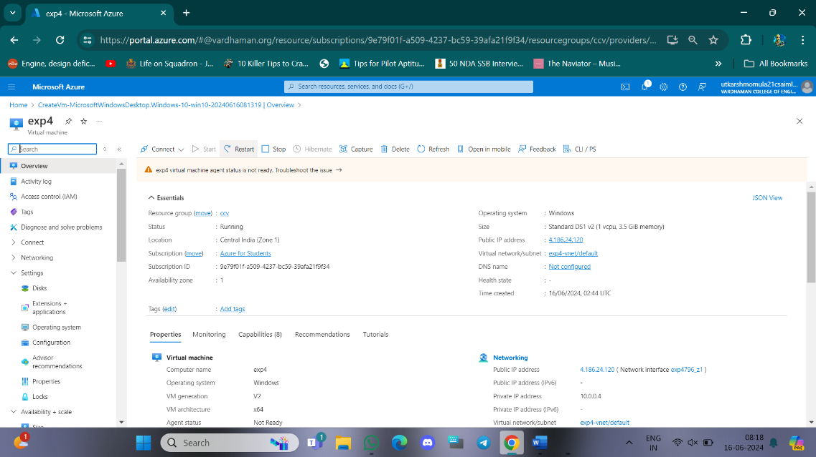

**Step-2: After deployment of VM stop VM for scaling.**

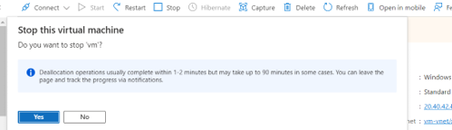

**Step-3: On the left side there will be settings and click on disks.**

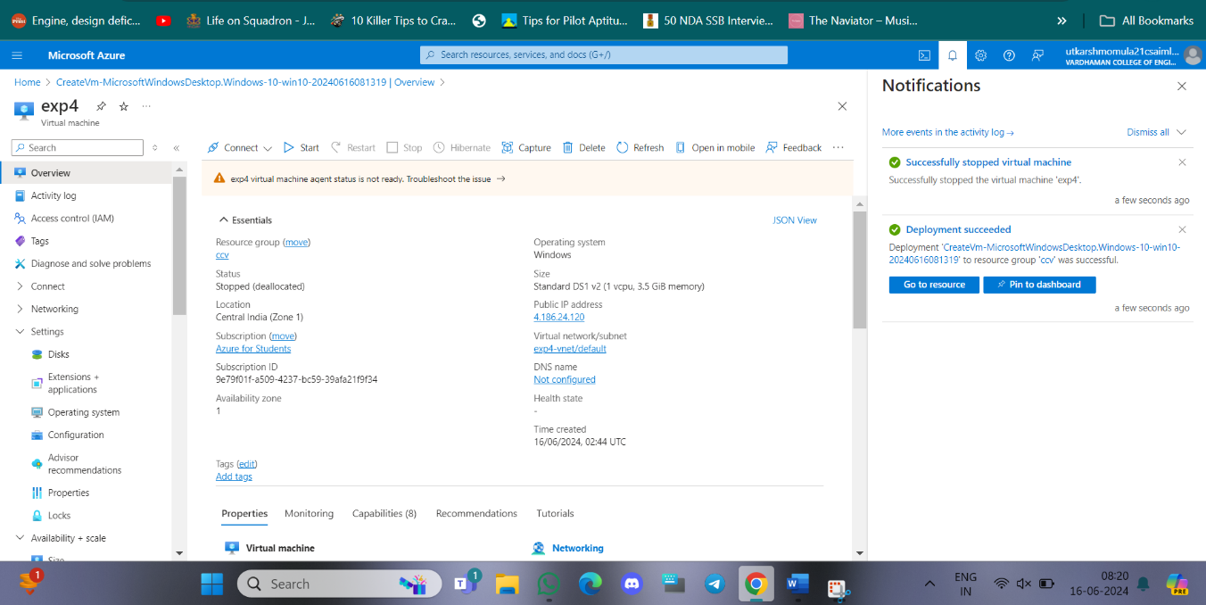

**Step-4: click on disk name and select your preferred size, save it.**

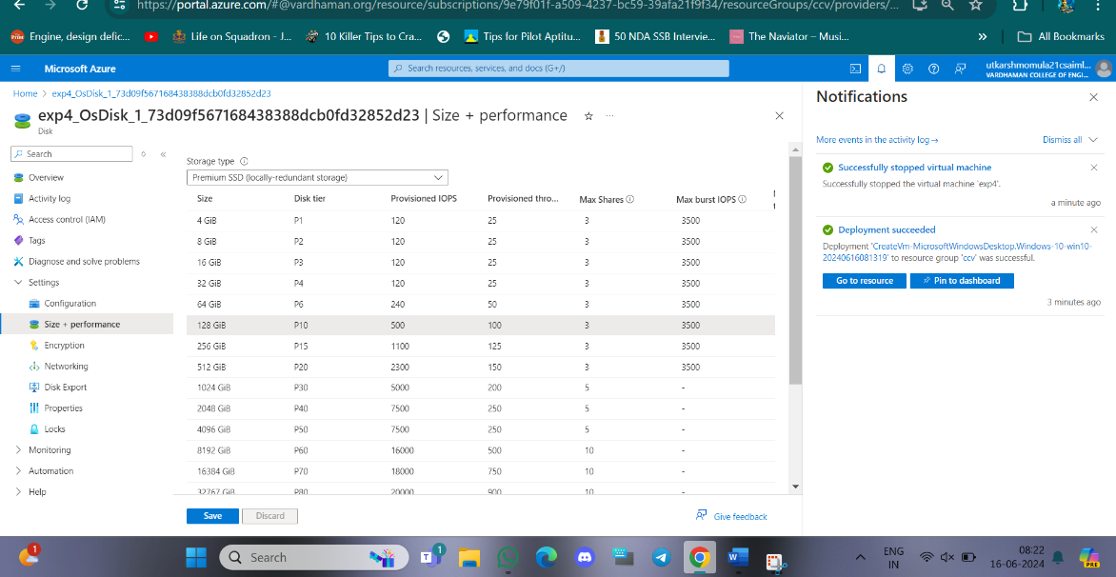

**Step-5: On the left side there will be select + performance and click on size then click on disk name and select your preferred ram size, save it.**

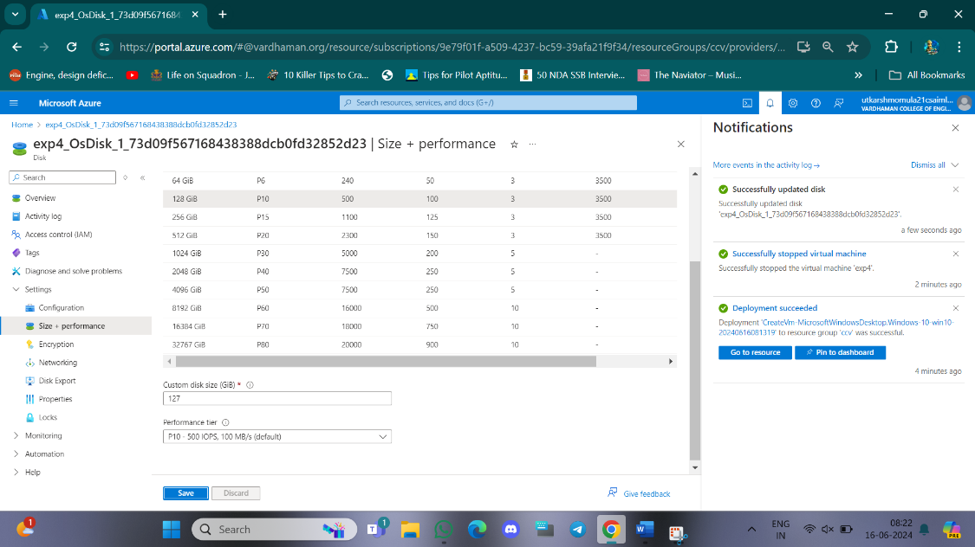

**Q5) Create a Virtual machine and do lock for VM in AZURE.**

**Step-1: Create a virtual machine (ubuntu or windows).**

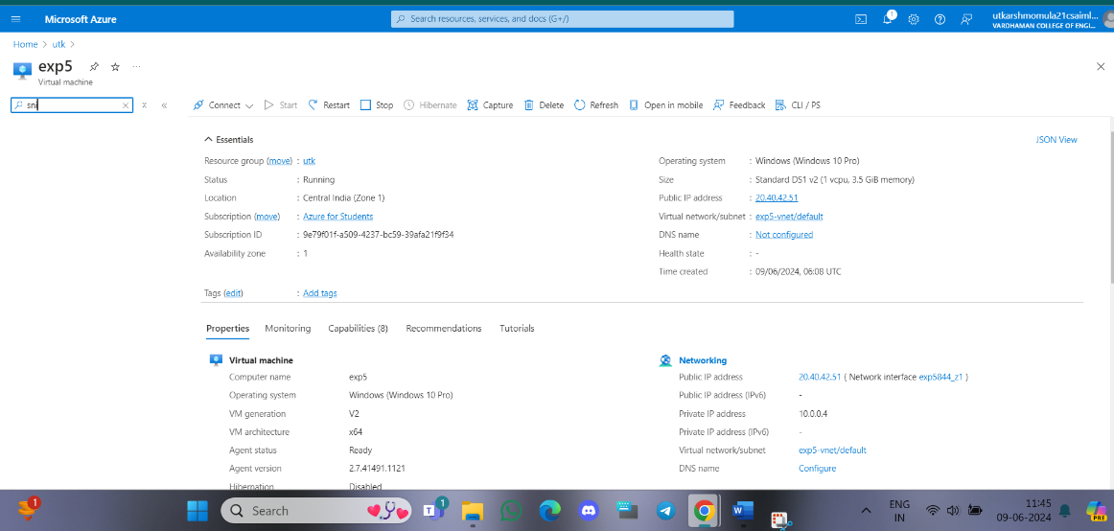

**Step-2: On the left side there will be settings and click on locks, give lock name and select lock type.**

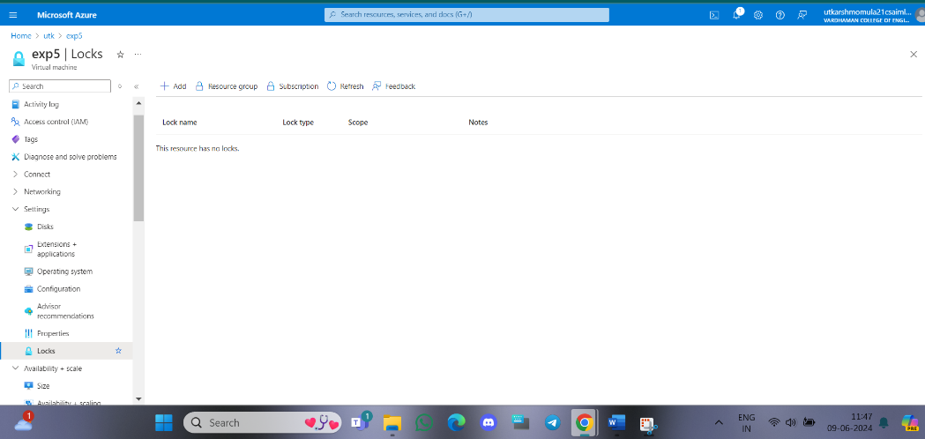

**Step-3: click on ok.**

**Similarly, you can do for Resource group and subscriptions.**

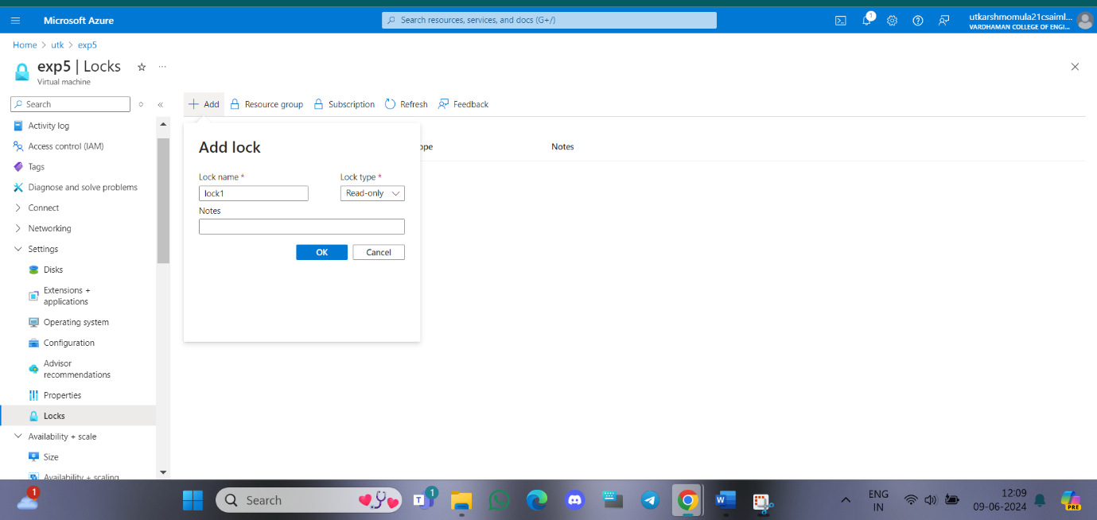

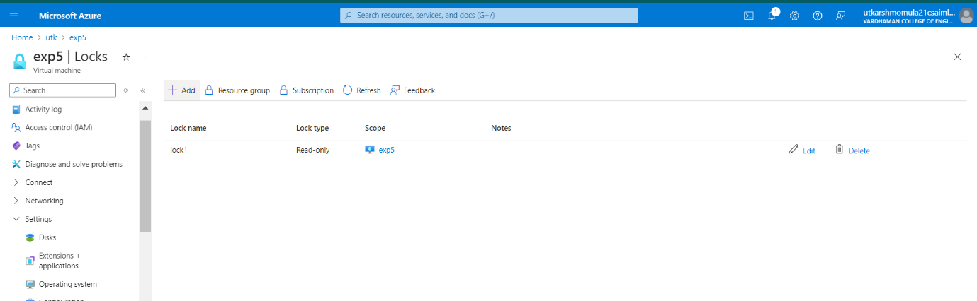

**Q6) Create Ubuntu VM and run a python program in it.**

**Step-1: Create a ubuntu virtual machine using SSH key same as previous experiment.**

**Step-2: Login with your username and type python3, write your python program and execute it.**

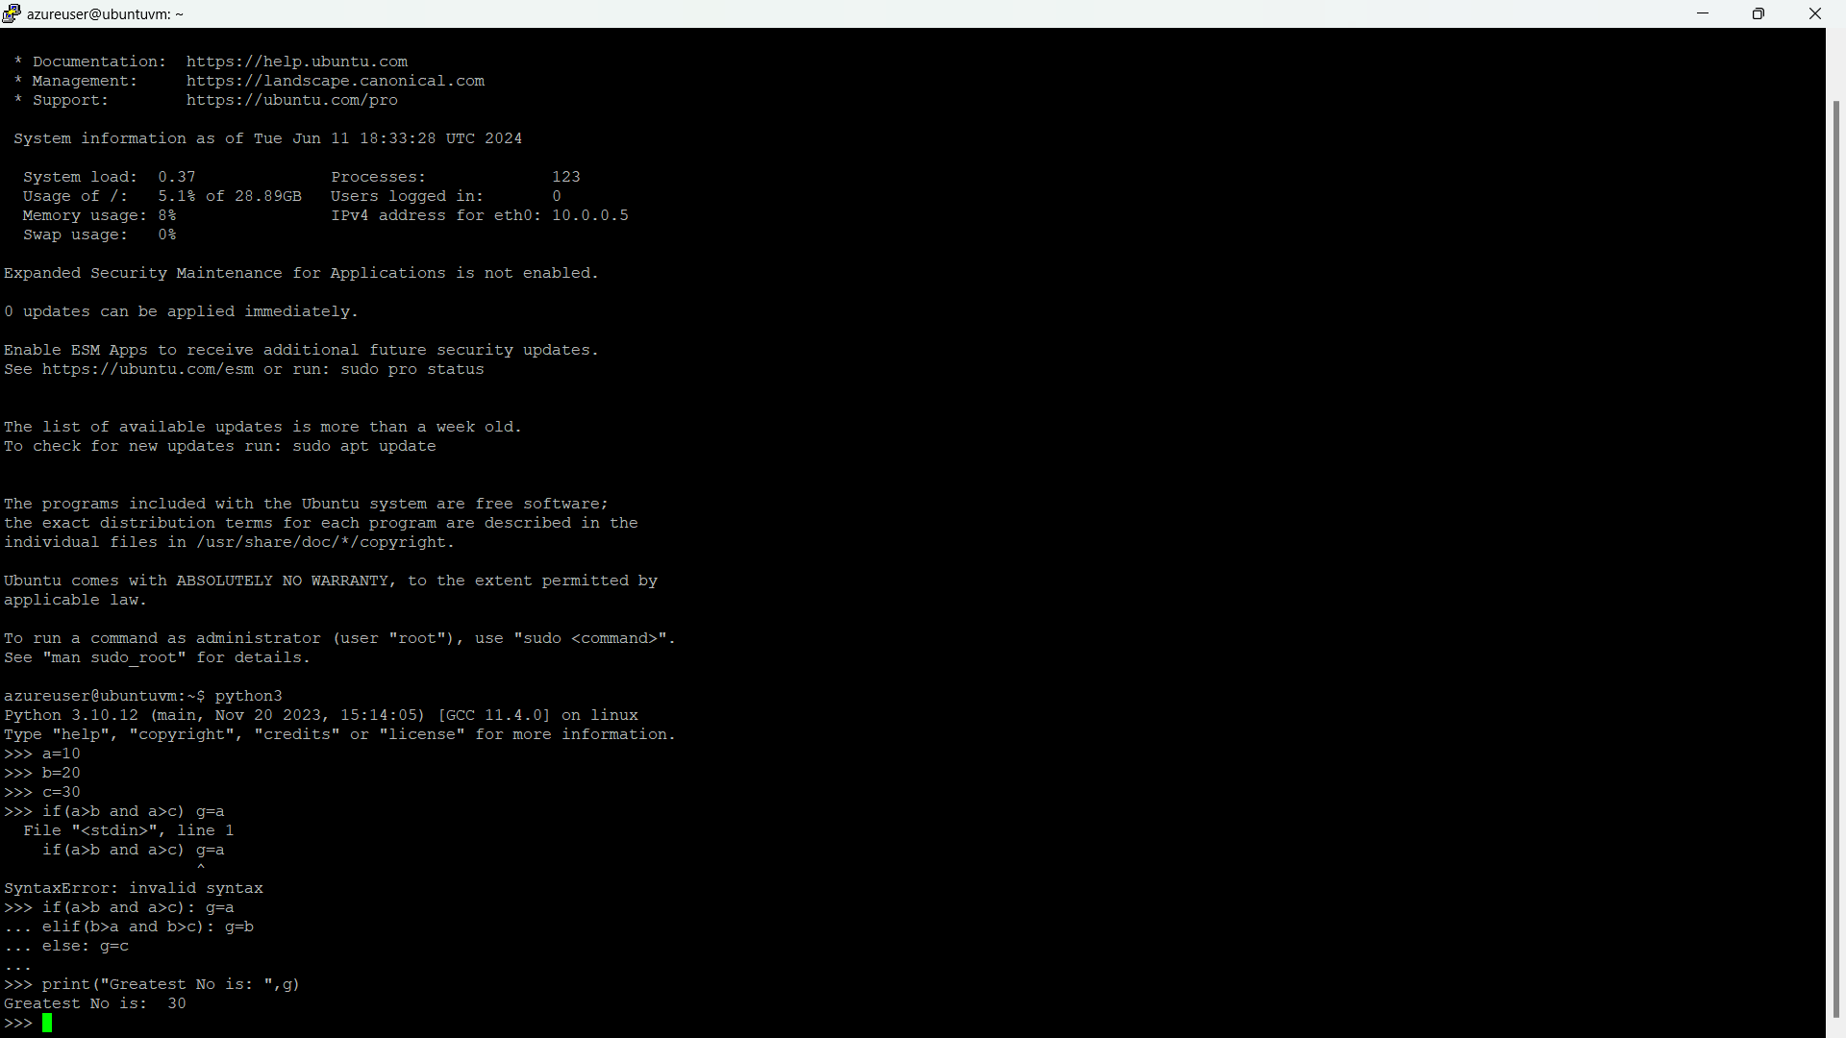

**Q7) Create a Ubuntu VM and transfer files using WinScp.**

**Step-1: Create a ubuntu virtual machine using SSH as previous experiment and copy public IP address.**

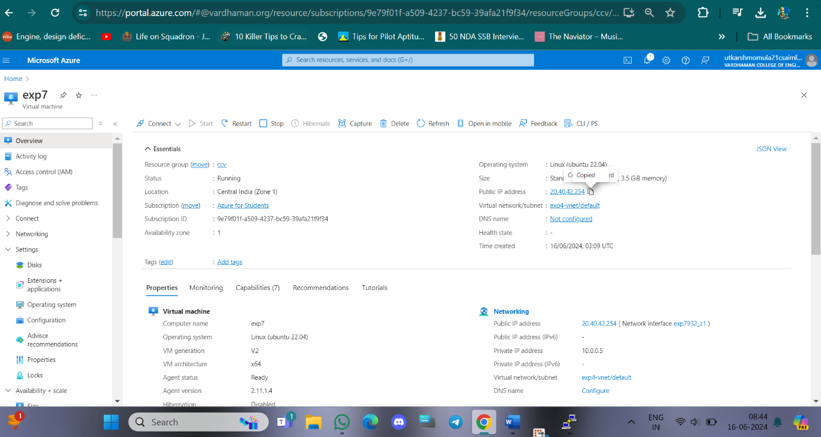

**Step-2: Login into your ubuntu VM using PUTTY and type ls command as you can see nothing.**

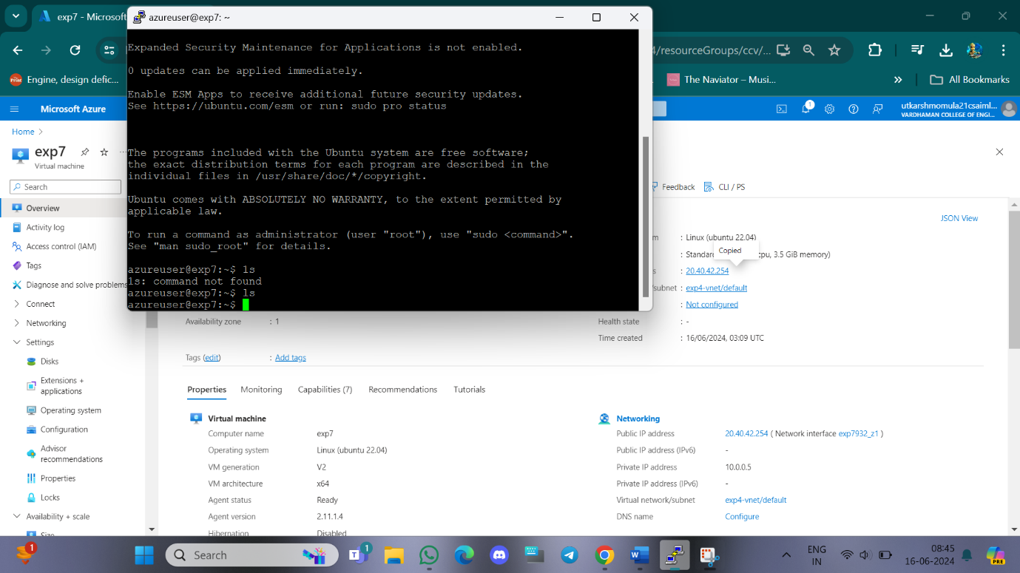

**Step-3: Open WinScp at right bottom you can see Advanced option->SSH->Authentication->In that drag private key file and click on ok.**

**At last Login into your account using public IP address and username in WinScp.**

**Now, you can drag your files from your desktop to ubuntu VM in WinScp.**

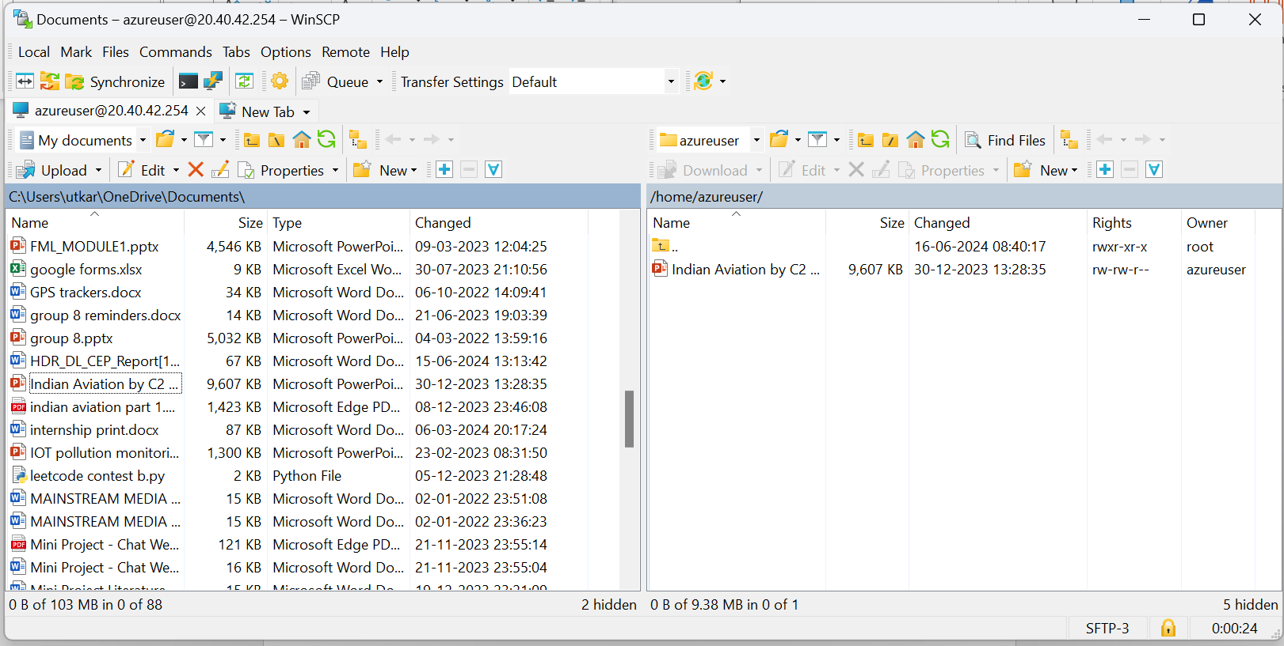

**Step-4: Now again type ls command as you can see file inside ubuntu VM.**

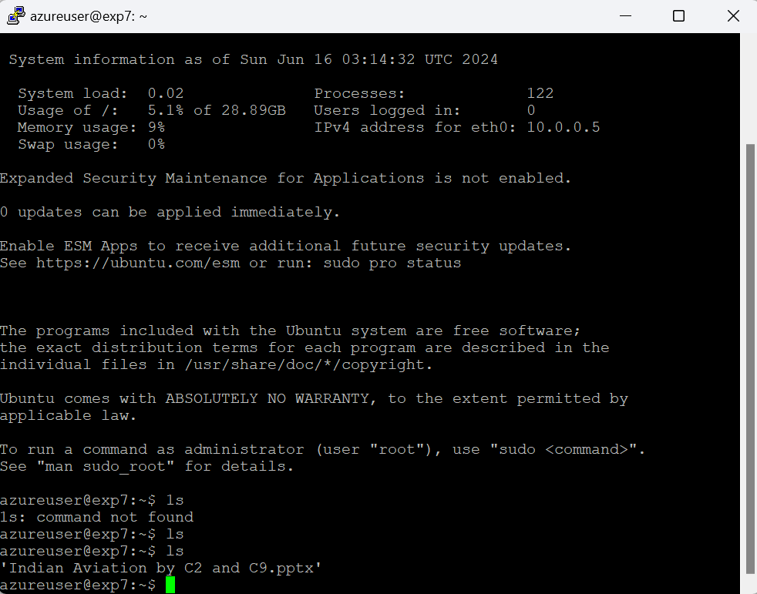

**Q8) How to make Linux server as web server in AZURE.**

**Step-1: Create a ubuntu virtual machine using SSH and enable HTTP port as well, as previous experiment and copy public IP address.**

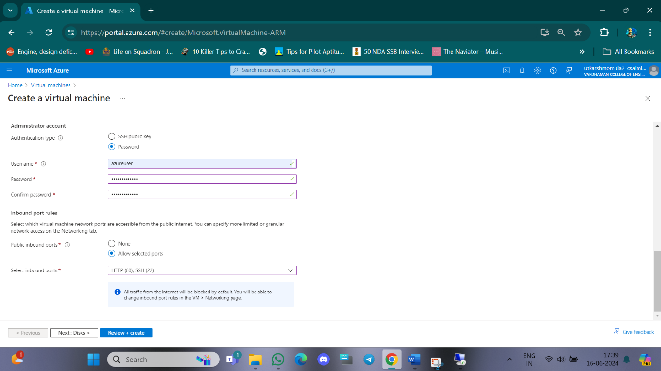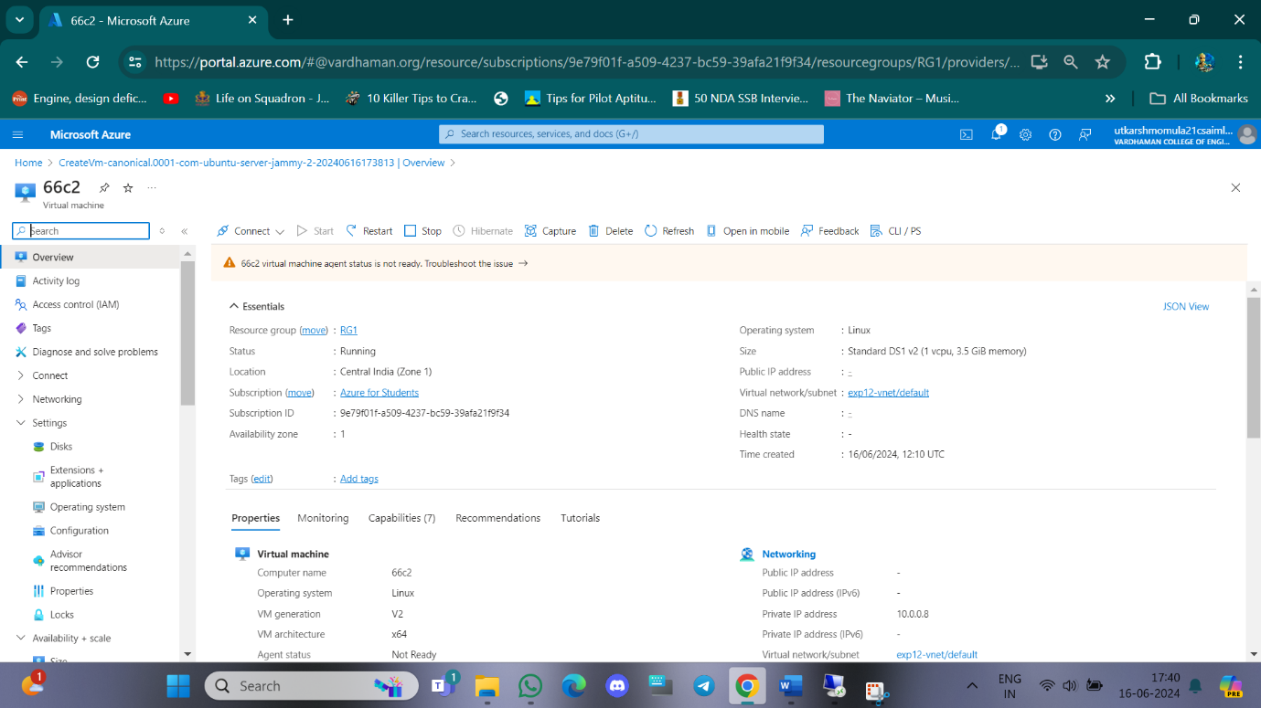

**Step-2:Login into your Ubuntu VM using your username and type the following commands.  
$sudo su**

**$sudo apt-get update**

**After typing the two command, now install web server using the below command**

**$sudo apt-get install nginx**

**After installing in VM, paste the public ip address in desktop browser and you can see.**

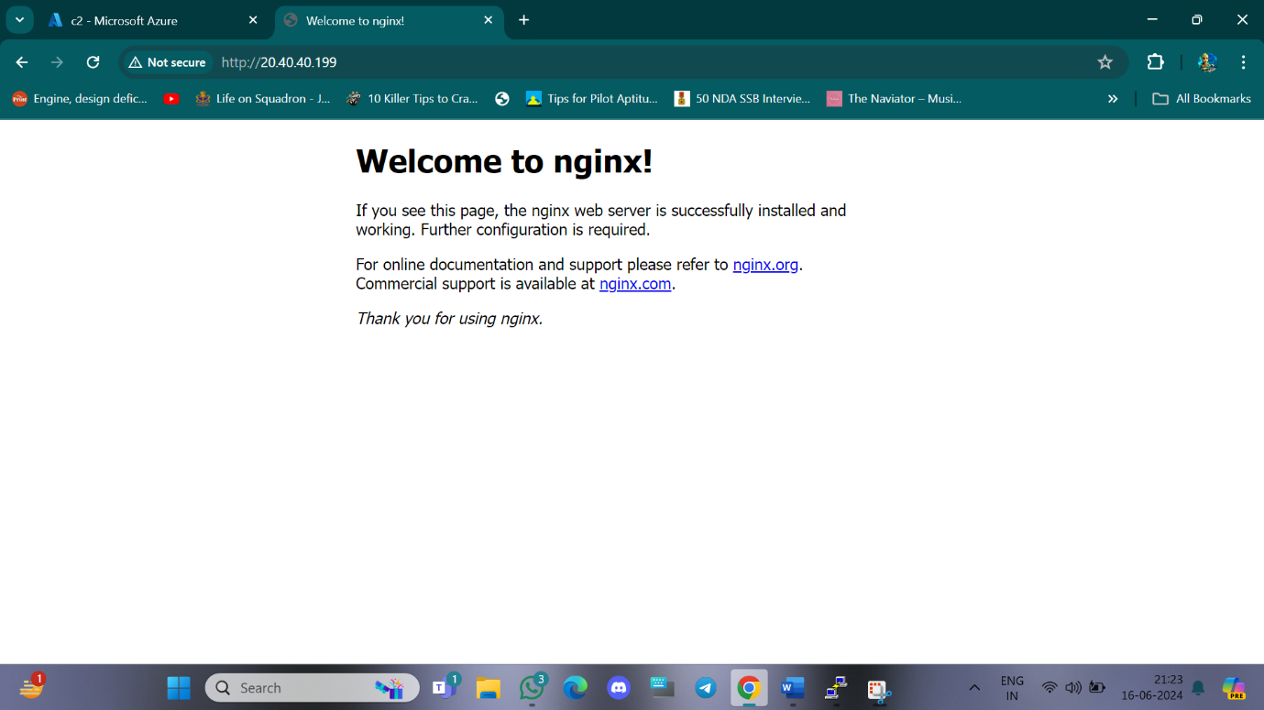

**Step-3: To remove following information and keep new information in that page type the following command and refresh the browser page.**

**$cd /var/www/html**

**$rm index.nginx-debian.html**

**$echo “Welcome to CSM “>index.html**

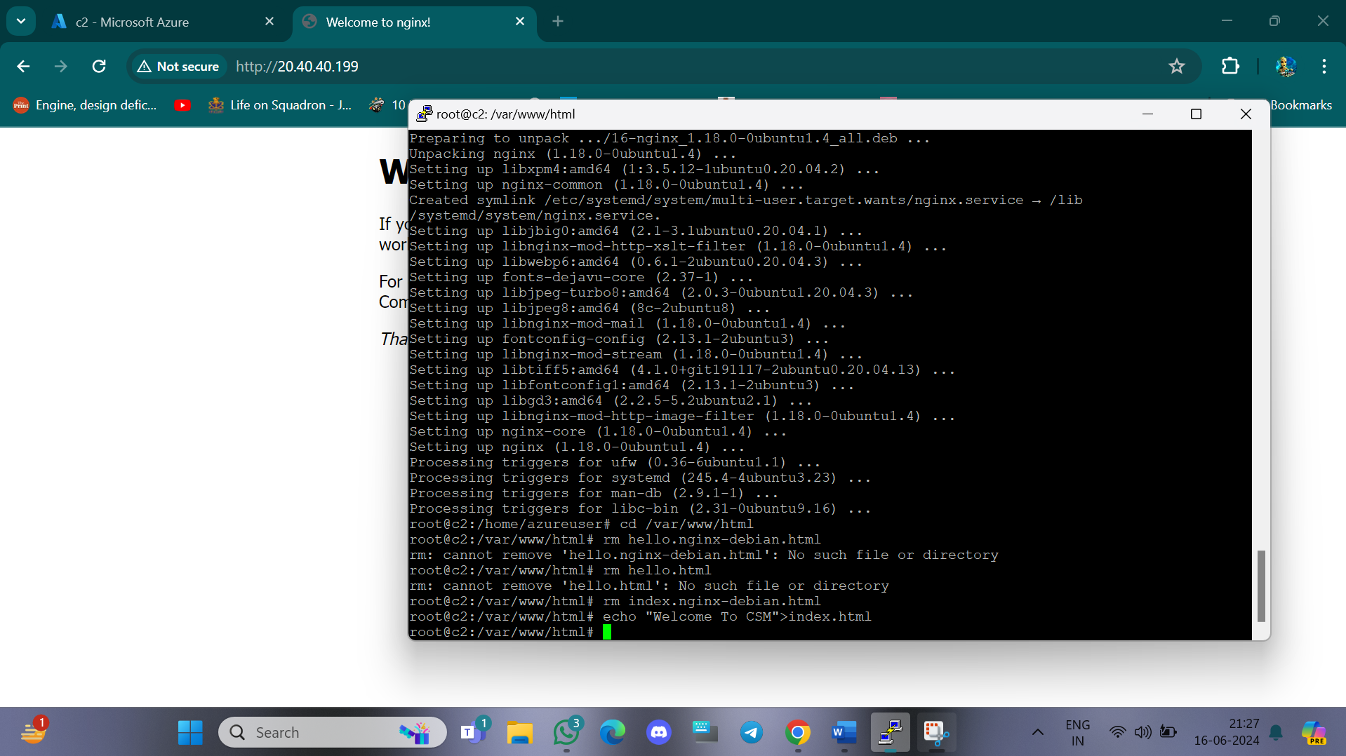

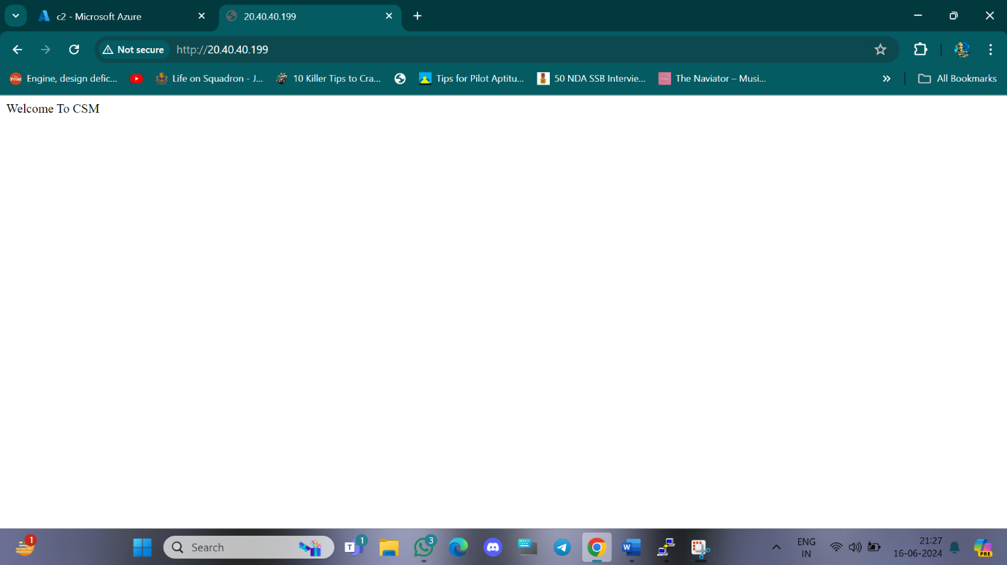

**Q9) Setup and configure AZURE web server for windows server(IIS).**

**Step-1: Create VM with Rdp and Http port enable and login windows VM same as previous experiment and copy public IP address.**

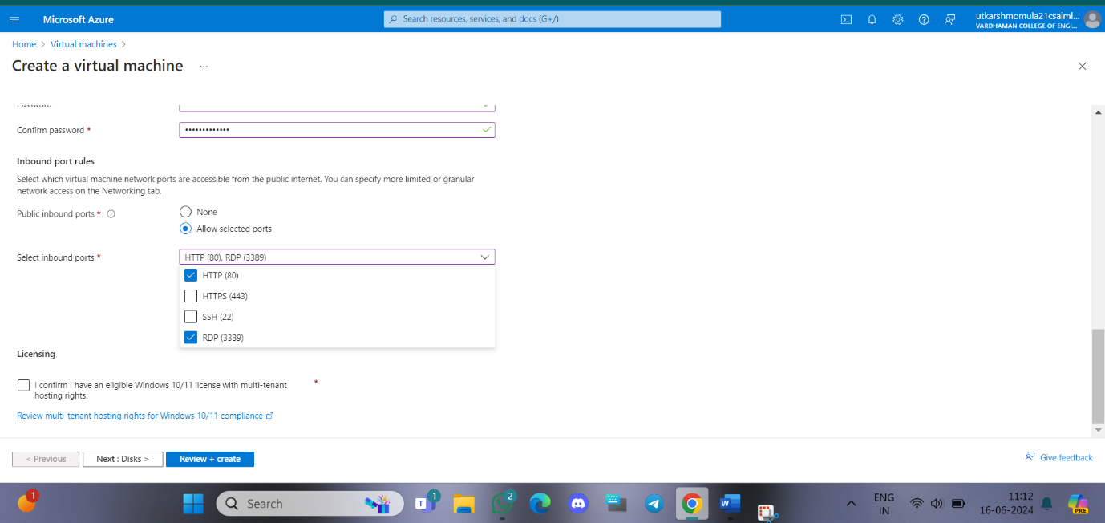

**Step-2: When remote desktop will start(windows vm) you can see there will be Sever Manager will be opened and in that you can see Configure this local server , Click on “Add roles and features”.**

**Step-3: Click on next, next and in Server Roles select Web Server(IIS) click on add feature ,click on next, next till you can get install button and click on install .**

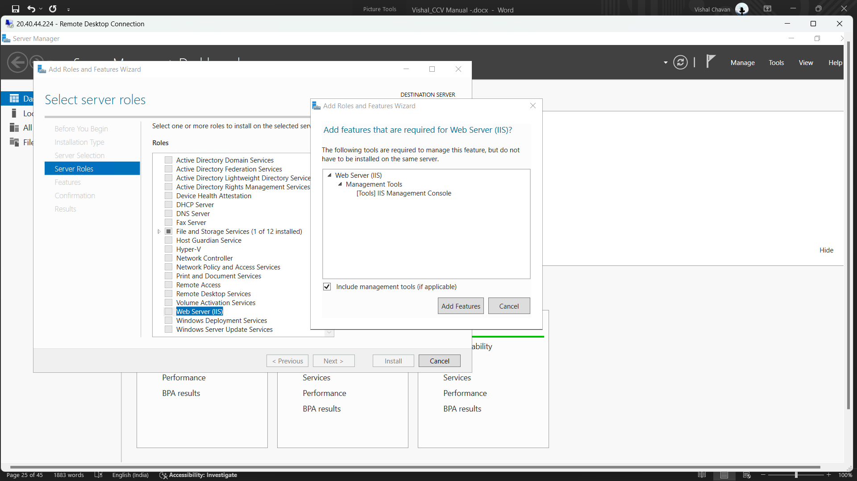

**Step-4: paste the public ip address in desktop browser and you can see.**

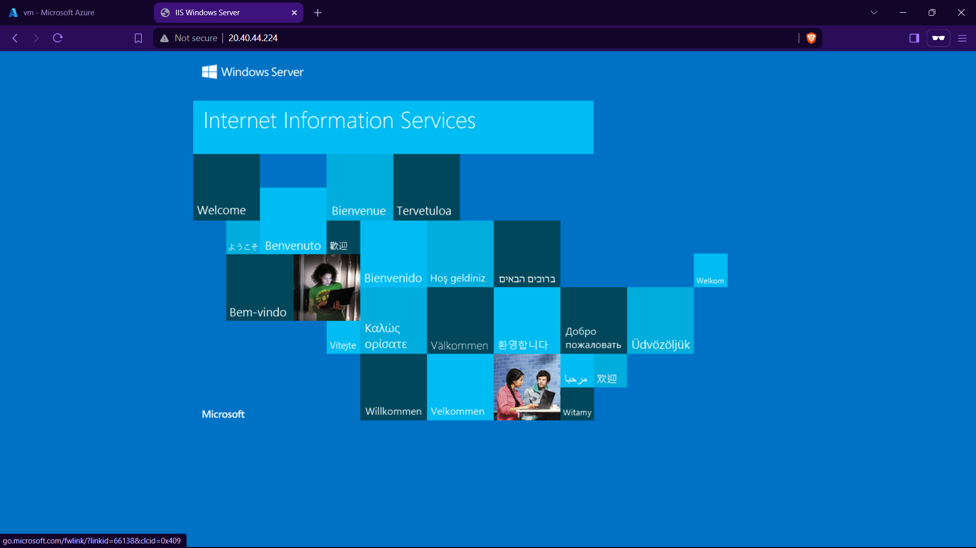

**Now to remove this all information first of all create index.html in desktop and**

**that should paste in the specified location of remote desktop VM that is ThisPC->windows(c)- >inetup->wwwroot and remove iistart png.**  **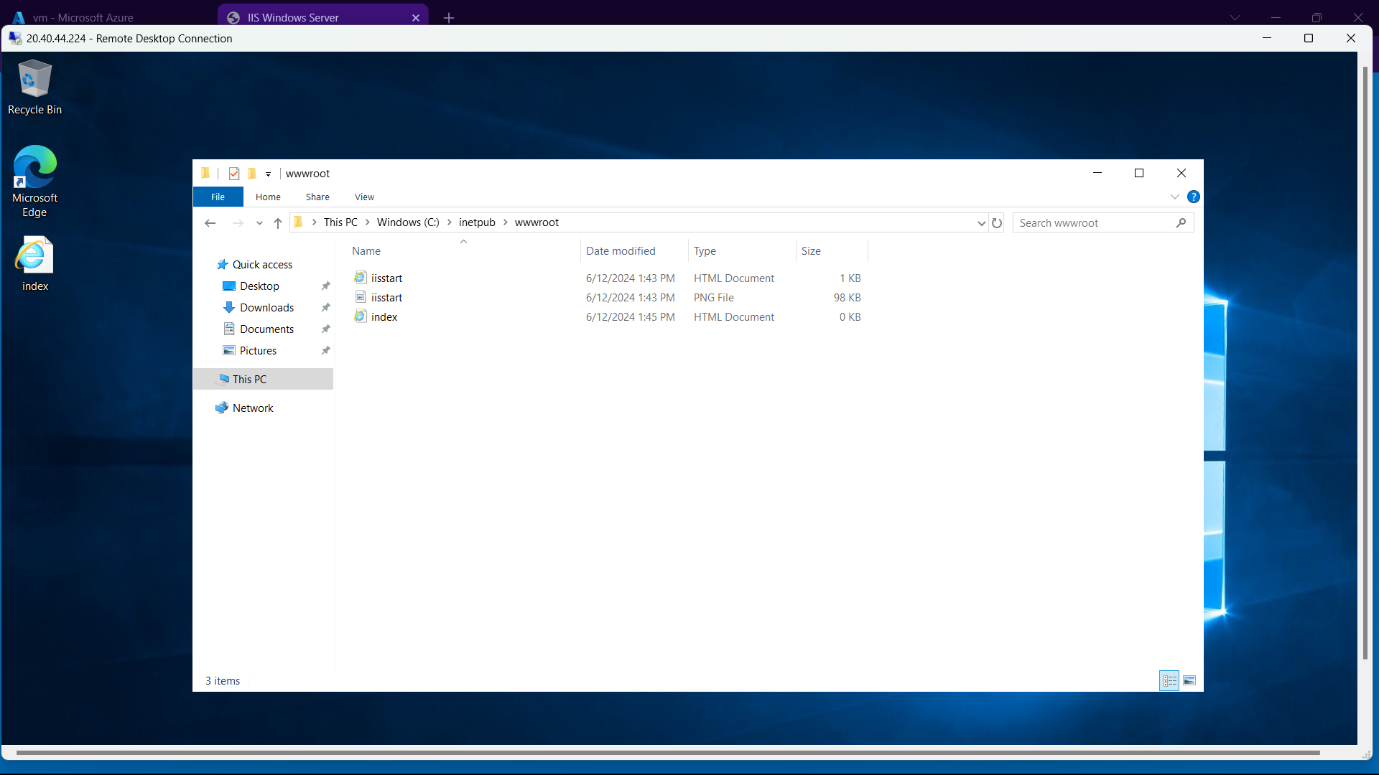  
Step-5: Refresh the browser page.**

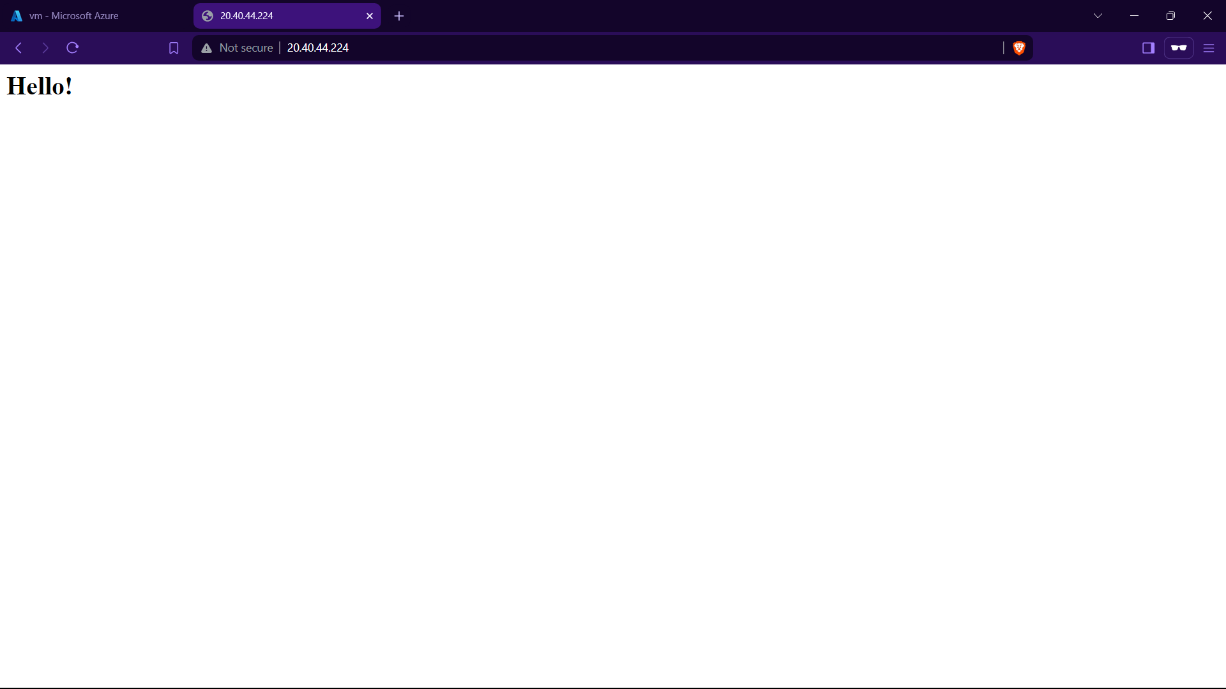

**Q10) Create Azure Storage Account, Container – Upload and Delete Objects(blob) in it.**

**Step-1:** Click On Storage Account and Create one and select redundancy as GRS/LRS.

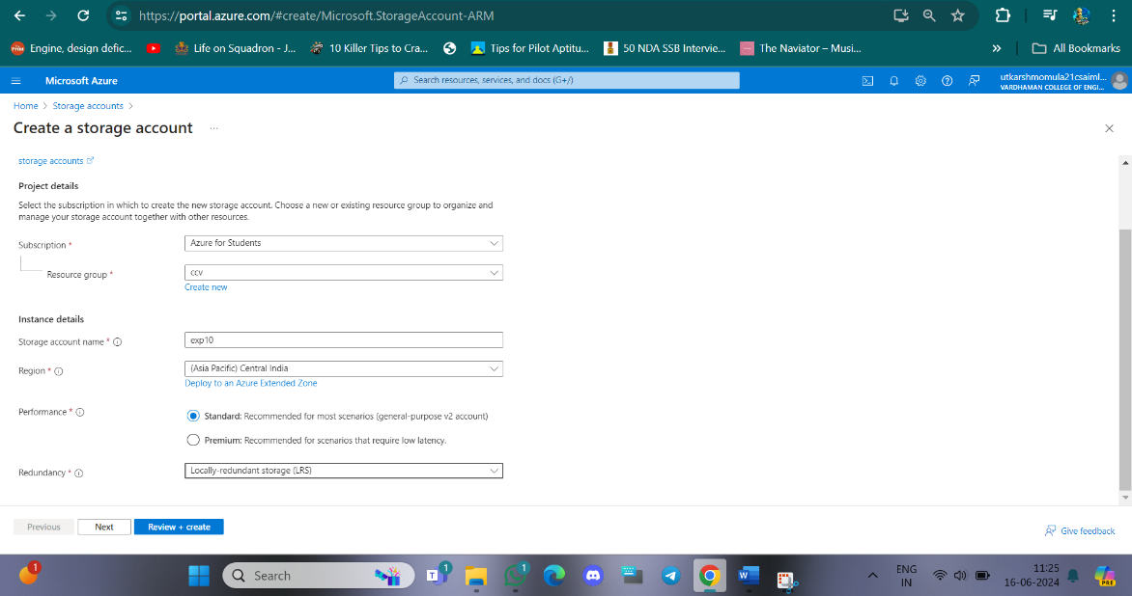

**Step-2:** Go to advance and Allow enabling anonymous access on individual containers.

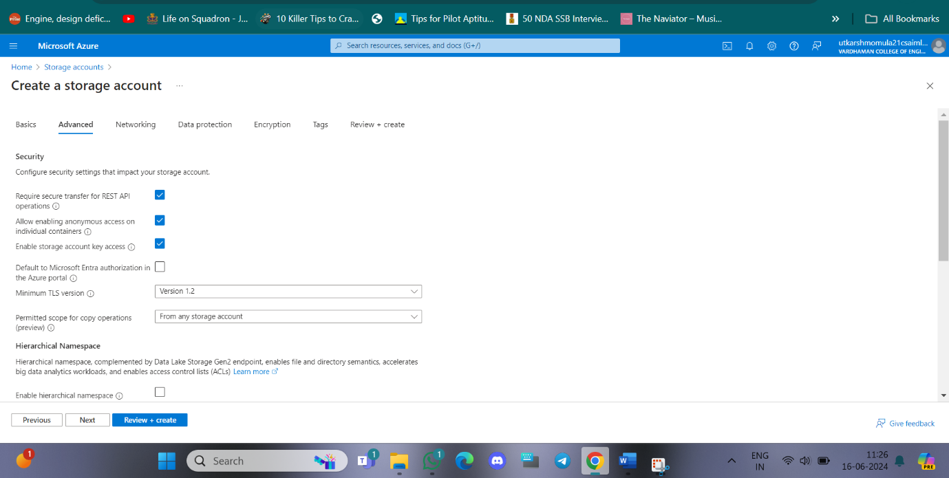

**Step-3:** After deployment Click on go to resource group and on Left Click on Containers and Create it with anonymous access level as blob(anonymous read access to blob only)

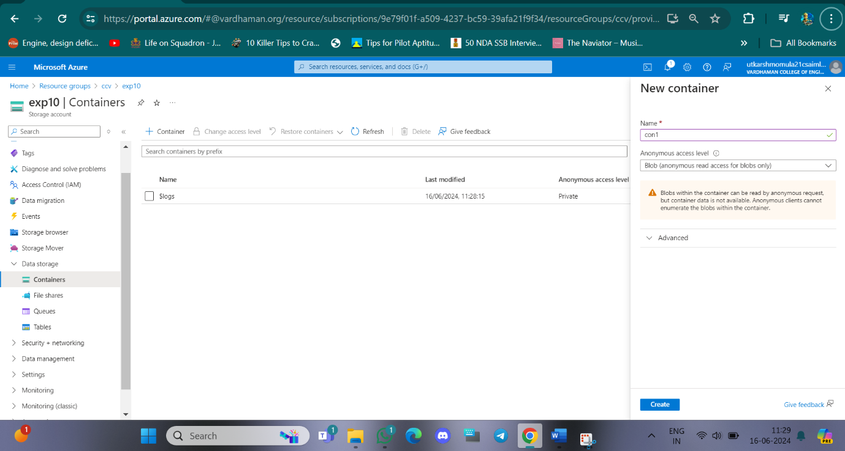

**Step-4:** Then open new container , click on upload and upload a file from desktop.

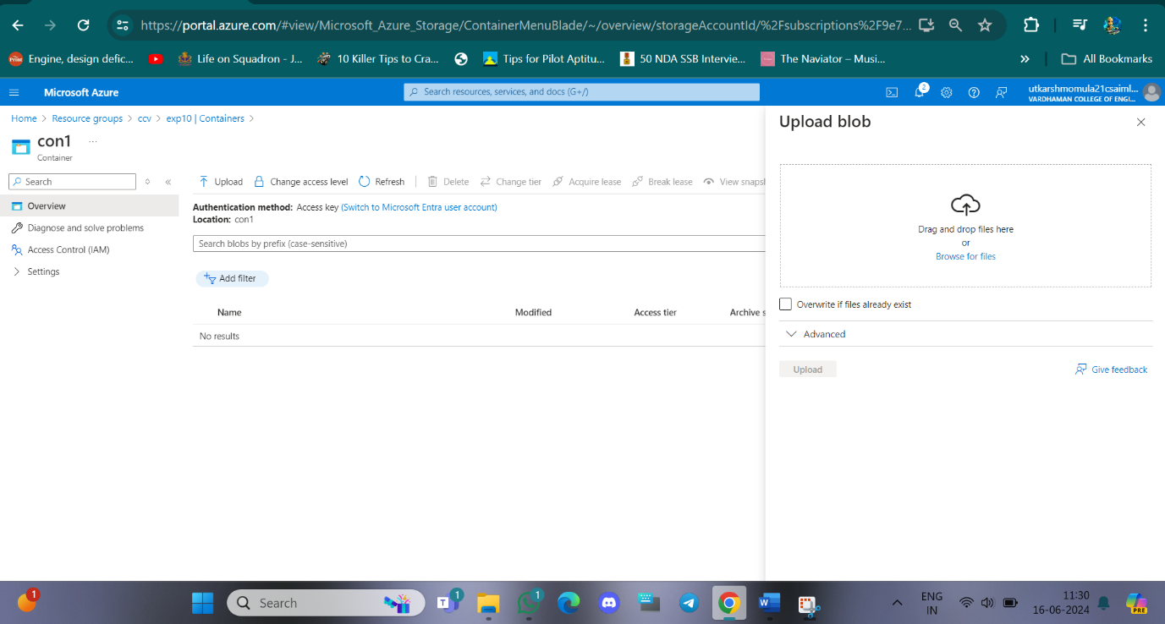

**Step-5:** Select the file and click on provided URL to open the file.

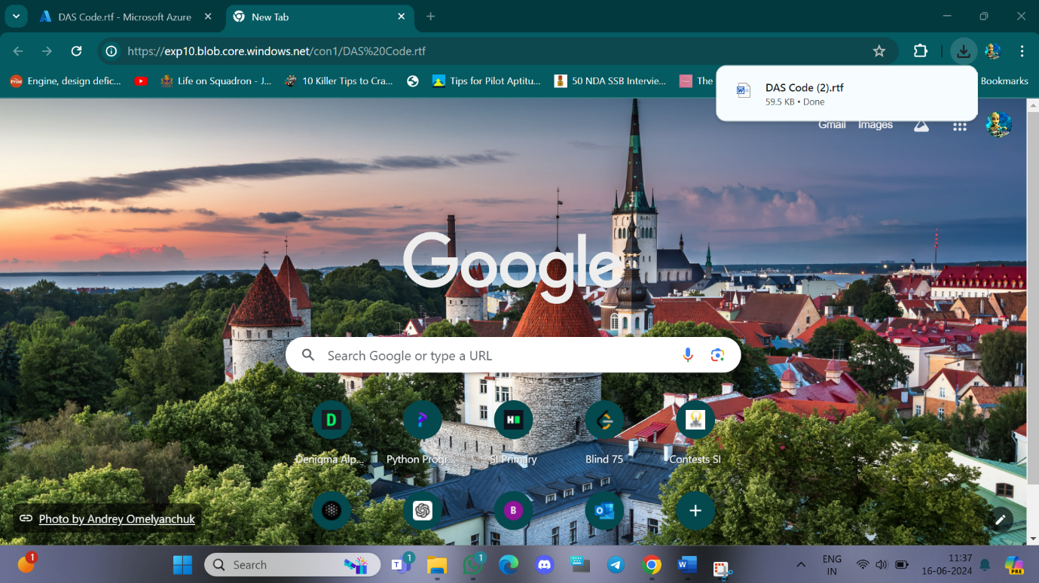

**Step-6:** On container click Change access level to Private(no anonymous access) and try to open the file in new tab it will show error.

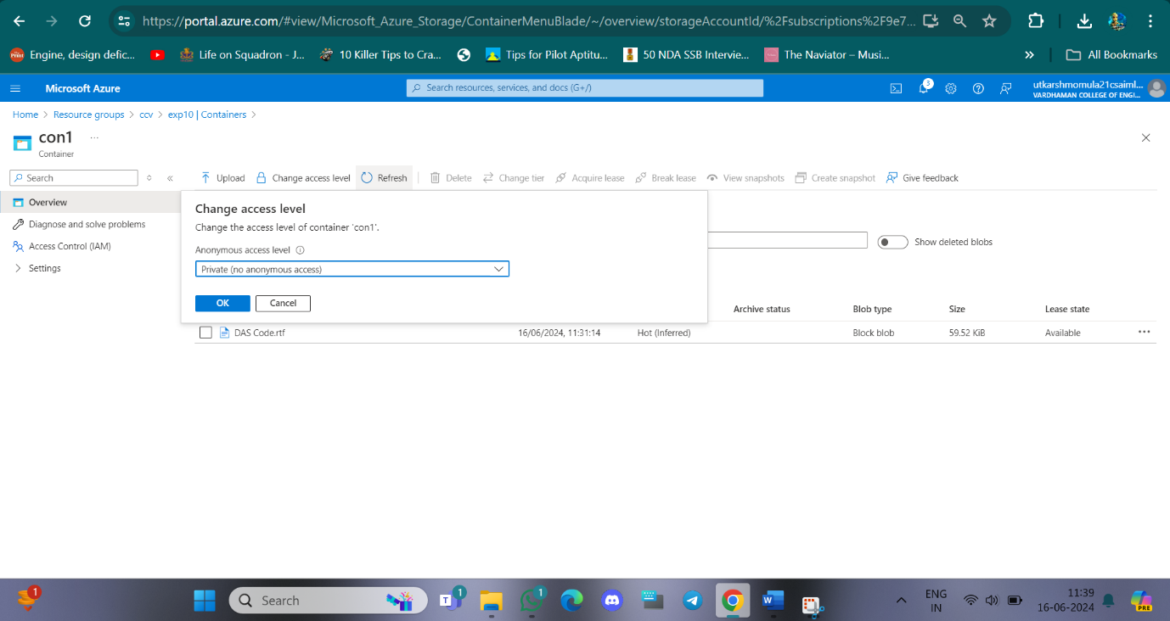

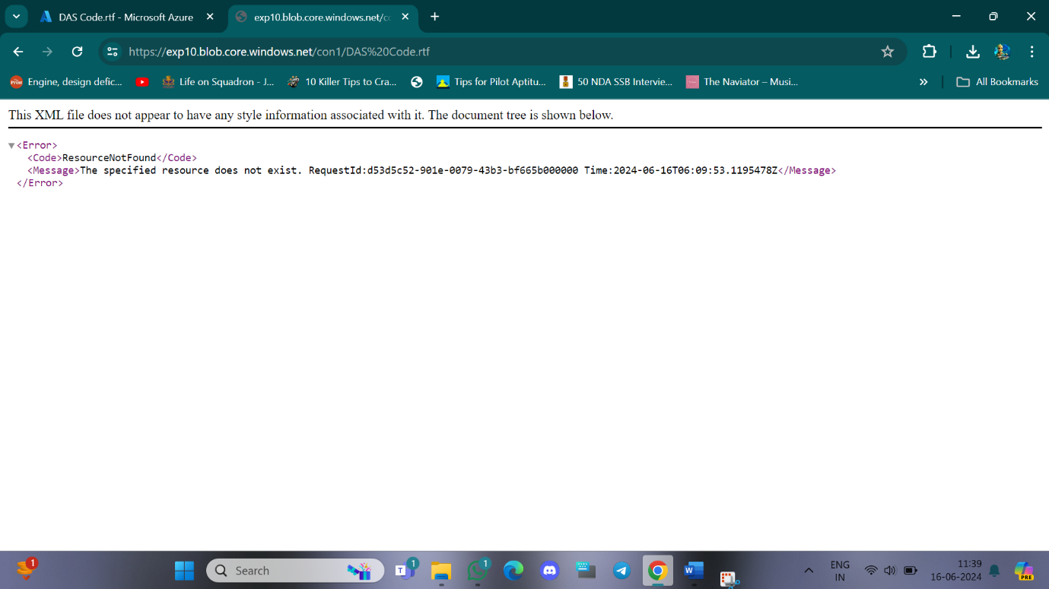

**Step-7:** Then delete blob container and storage account.

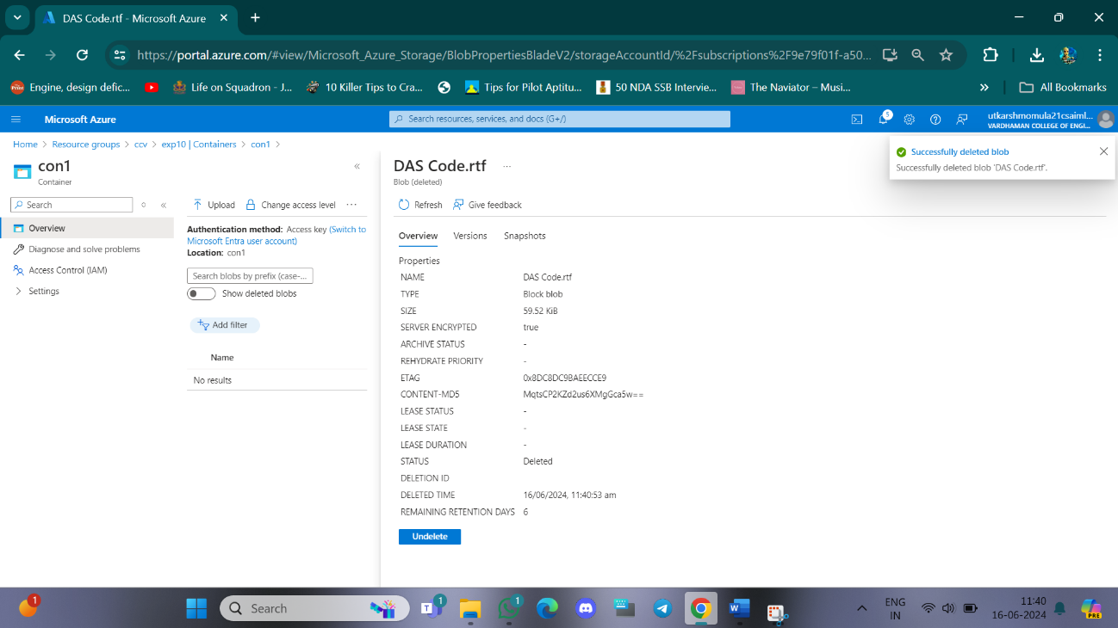

**Q11) Move Server Files from one Resource Group to another**.

**Step-1:** Create ResourceGroup1 , ResourceGroup2 and a Virtual machine on ResourceGroup1.

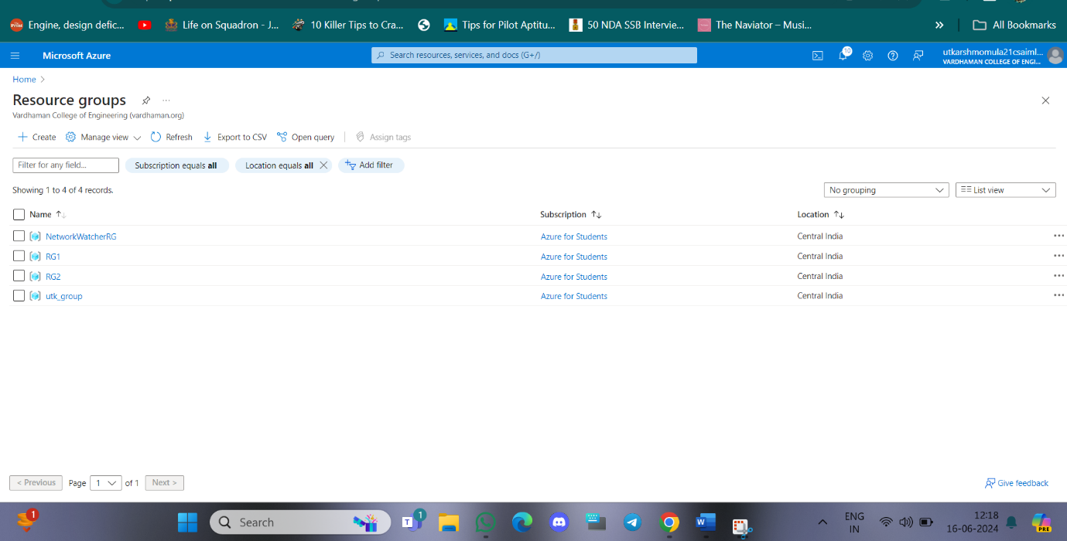

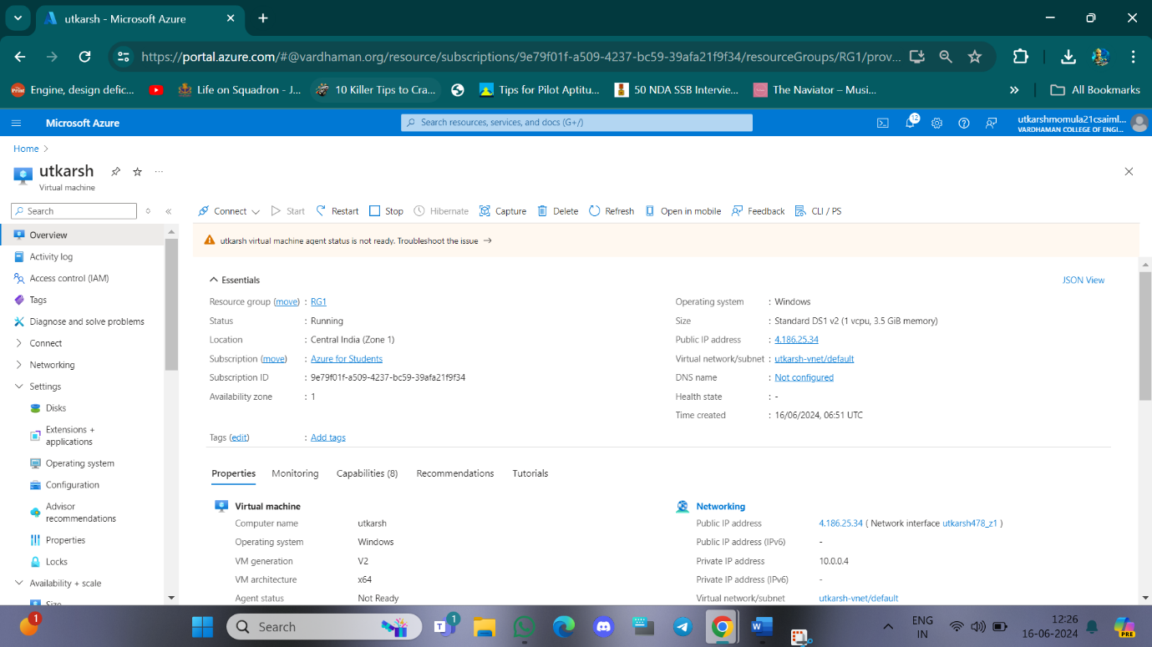

**Step-2:** Select all the resources from ResourceGroup1 and then click on Move->Move to another resource group.

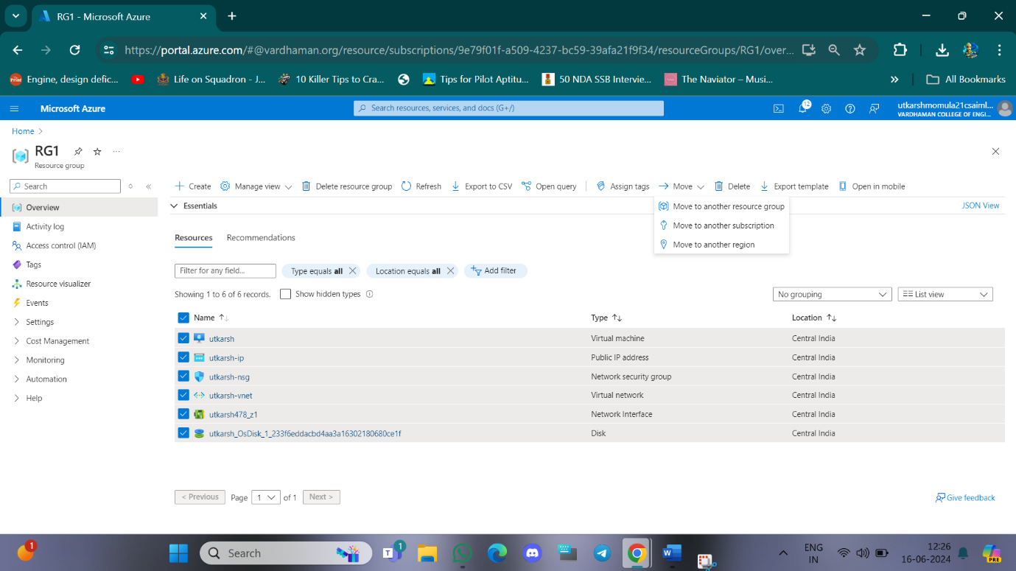

**Step-3:** Select the target Resource Group as ResourceGroup2 and click on move.

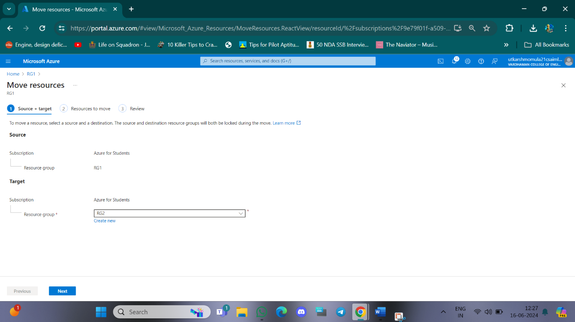

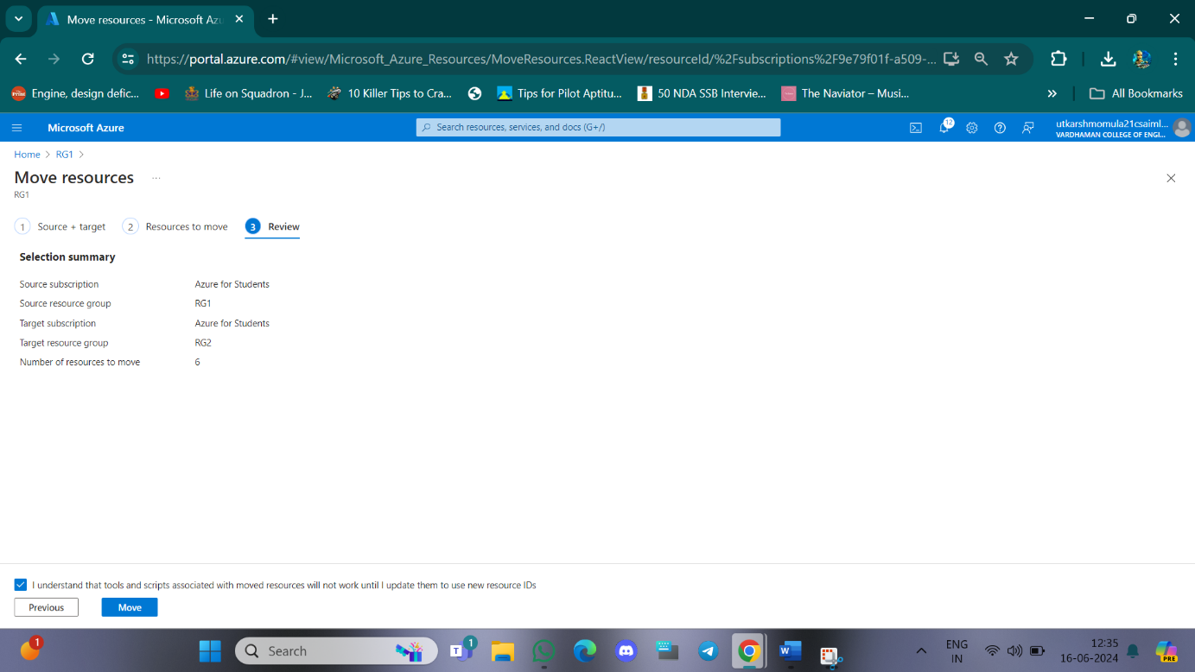

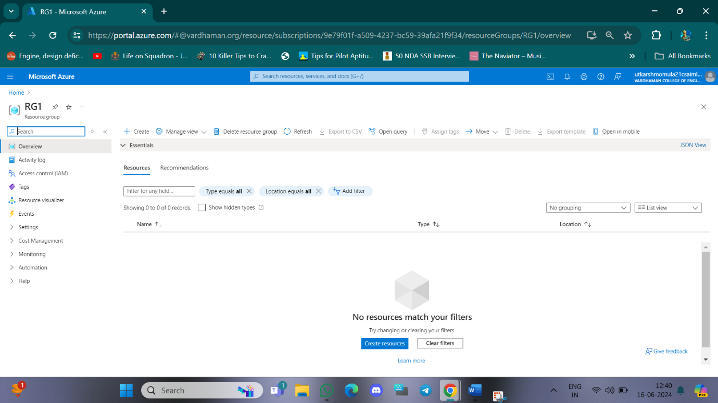

**Q12) How we are adding new users, login credentials, changing owner, create authorized key files.**

**Step-1: Create a ubuntu virtual machine using SSH as previous experiment.**

**Step-2: Login into your Ubuntu VM using your username and type the following commands.**

**To add new user in Linux server:**

**$sudo useradd -m vishal**

**To set new password:**

**$sudo password vishal**

**Enter new password and Retype password.**

**To modify login credentials:**

**$sudo usermod -aG sudo vishal**

**To switch the user:**

**$sudo su vishal**

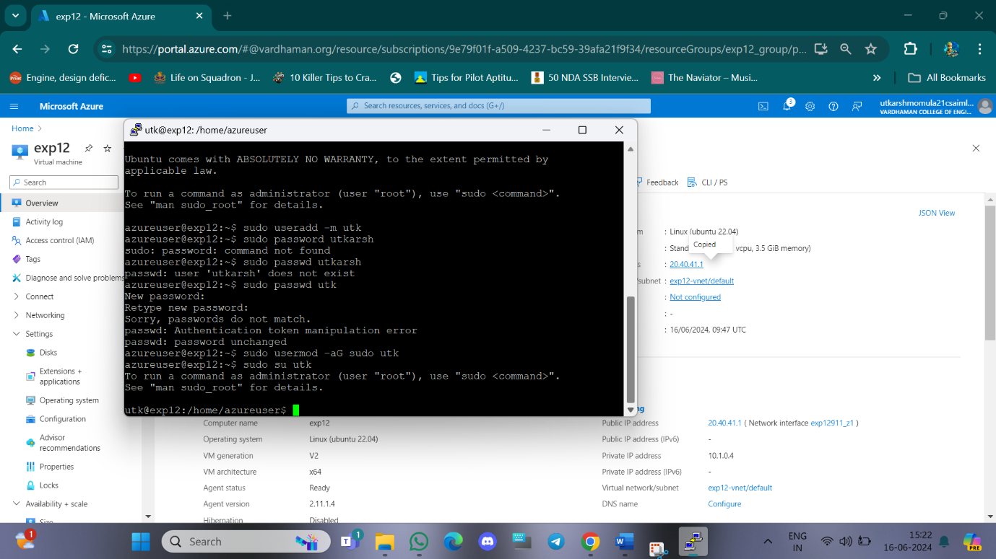

**Q11) Create a Windows VM and transfer files from desktop to remote desktopVM.**

**Step-1: Create Windows VM same as previous experiments and copy public IP Address.**

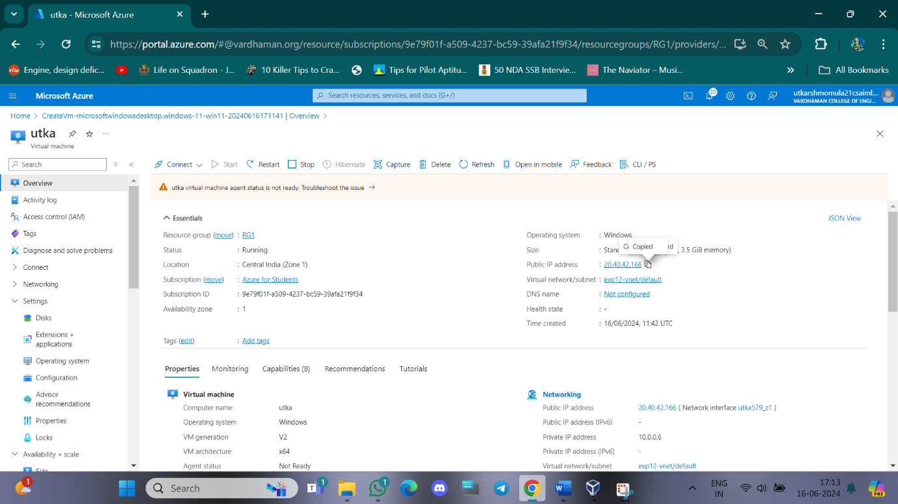

**Step-2: Login into your account using username and password using remote desktop.**

**Step-3: Minimize the Remote desktop and copy file from desktop.**

**Right click in remote desktop and click on paste.**

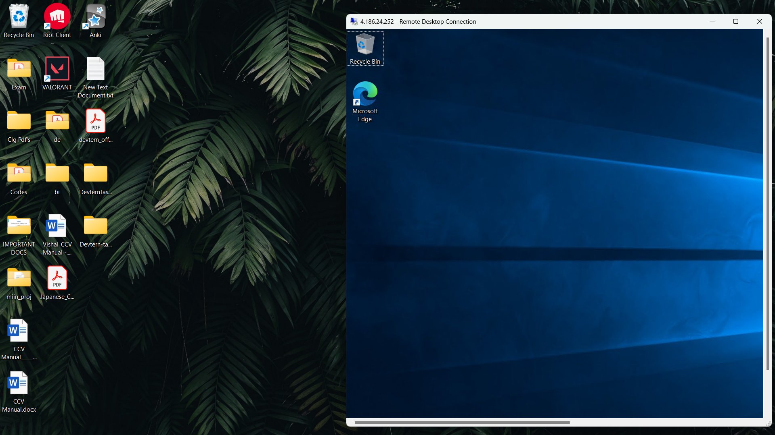

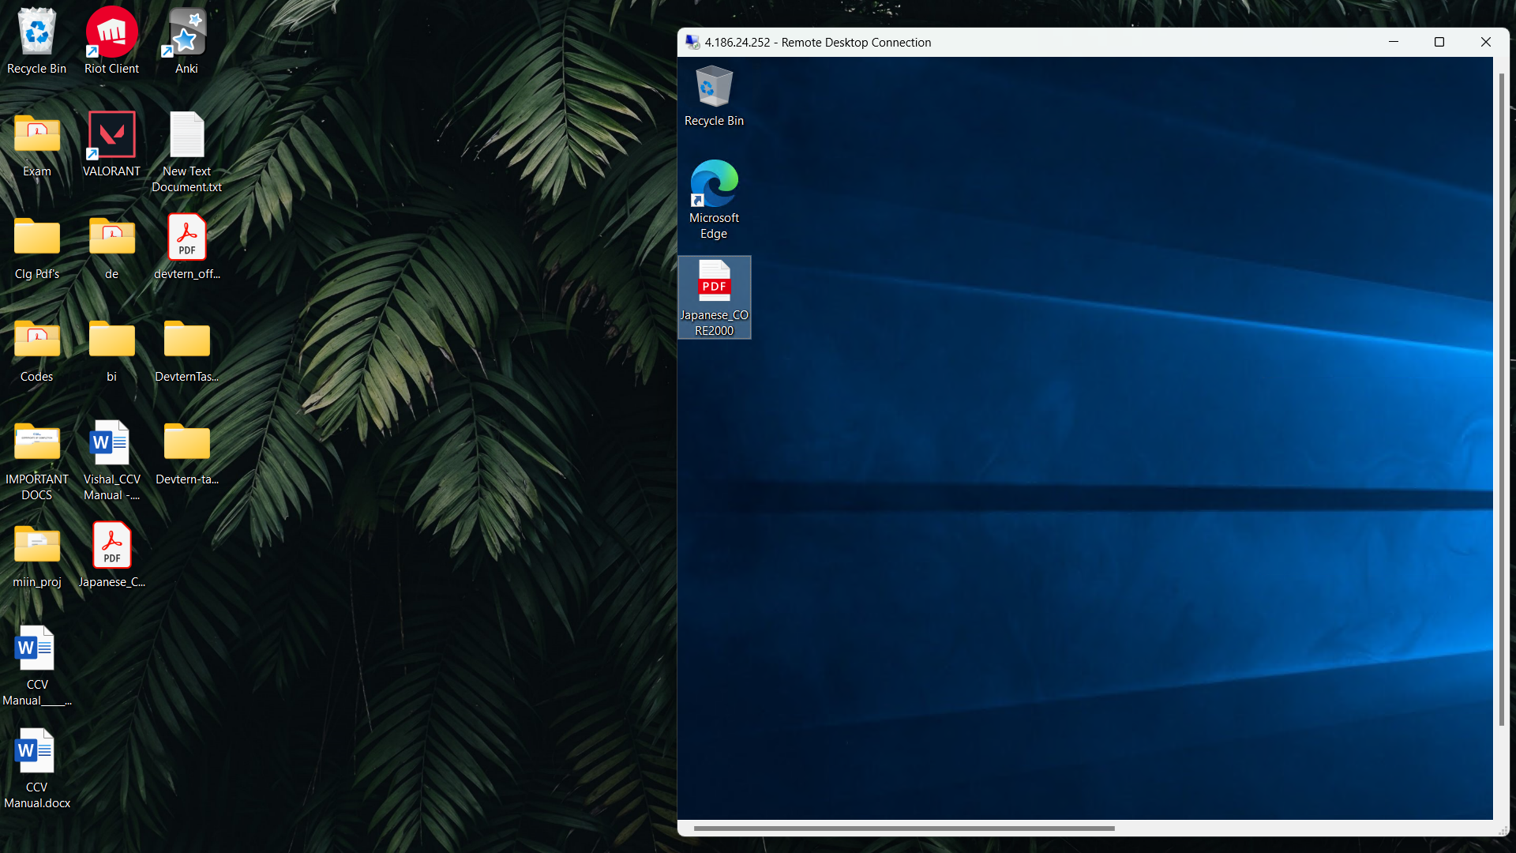

**Q12) How to attach and detach data disk to Windows Server in Azure data center**

Step-1: Create Virtual Machine with username and password and click on Next: Disks

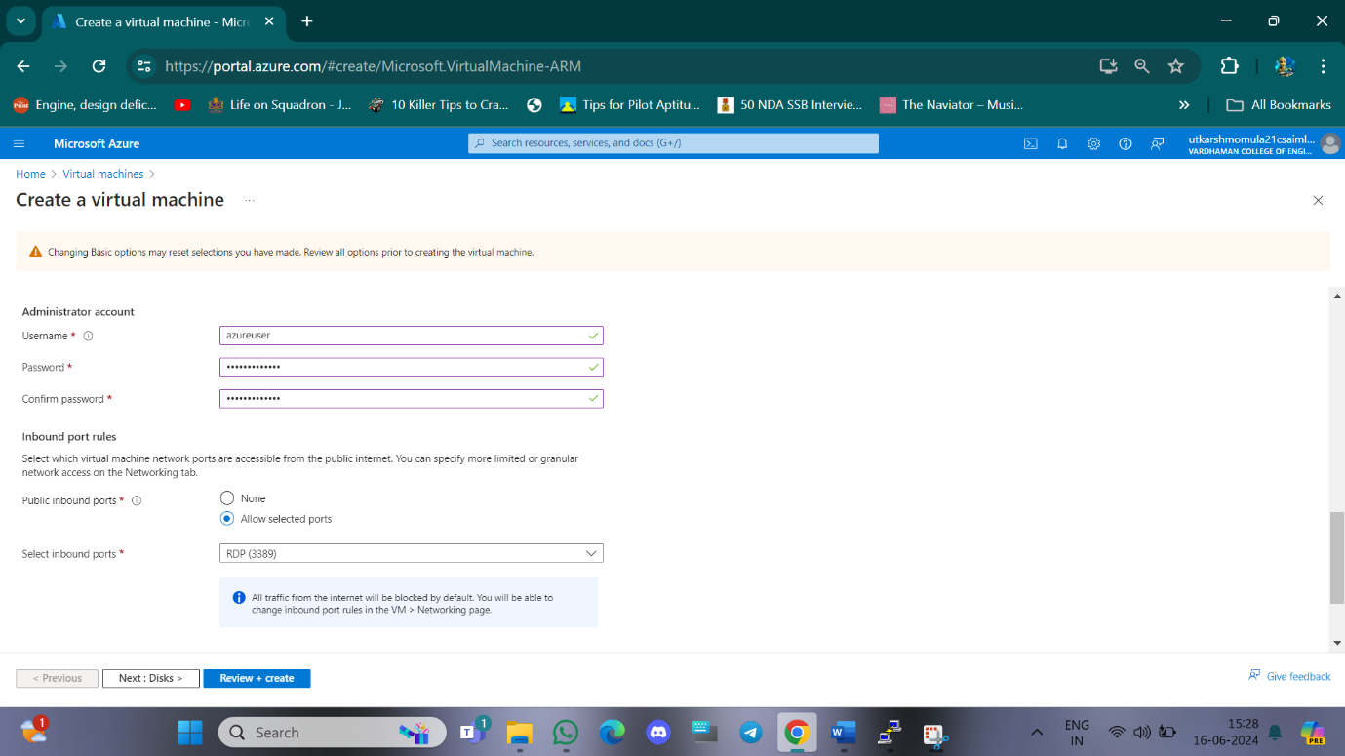

Step-2:Click on create and attach new disk

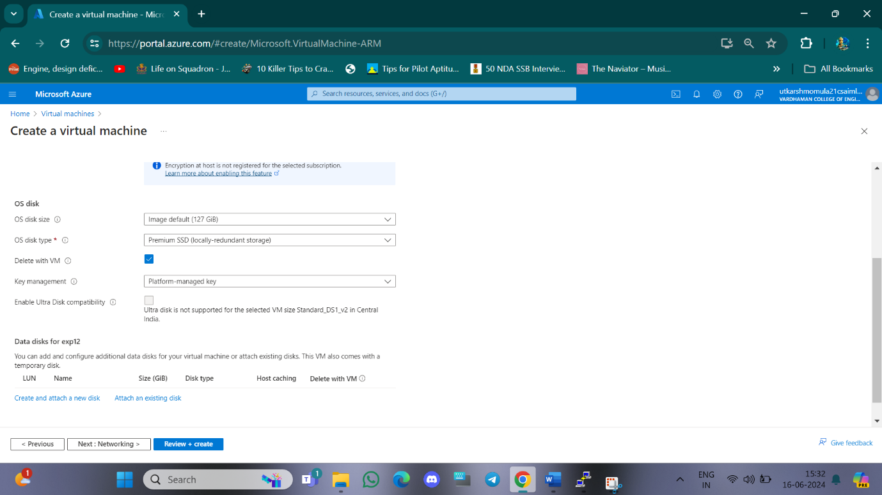

Step-3: Click on change size and select 10GiB and click on ok.

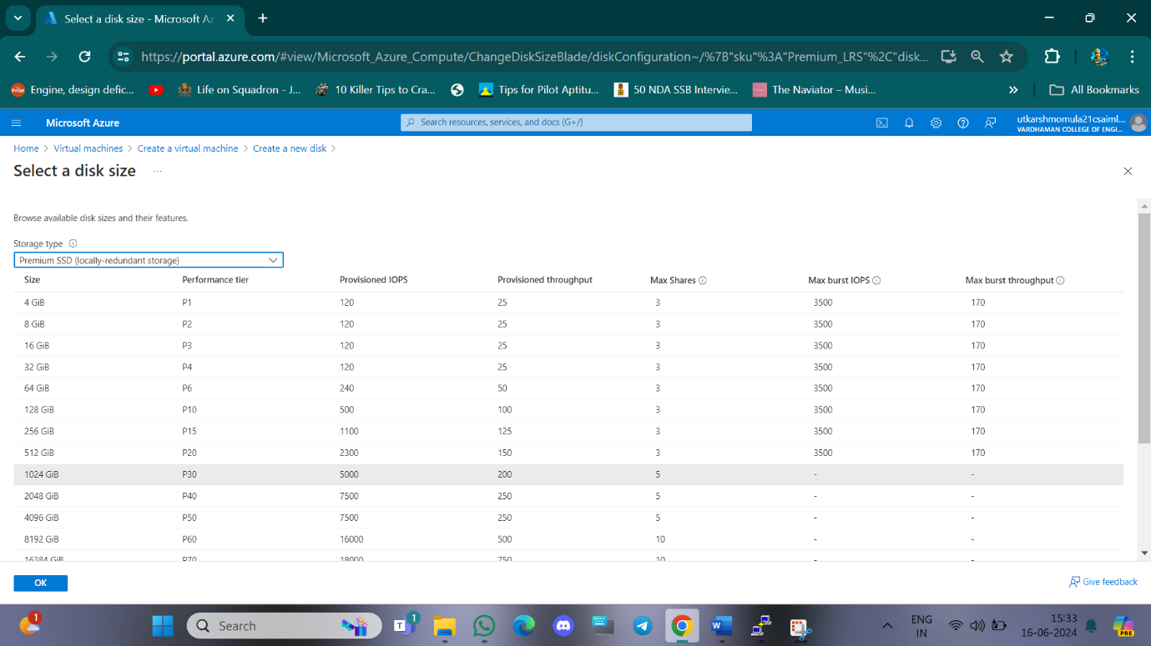

Step-4: Select delete disk with VM and click OK

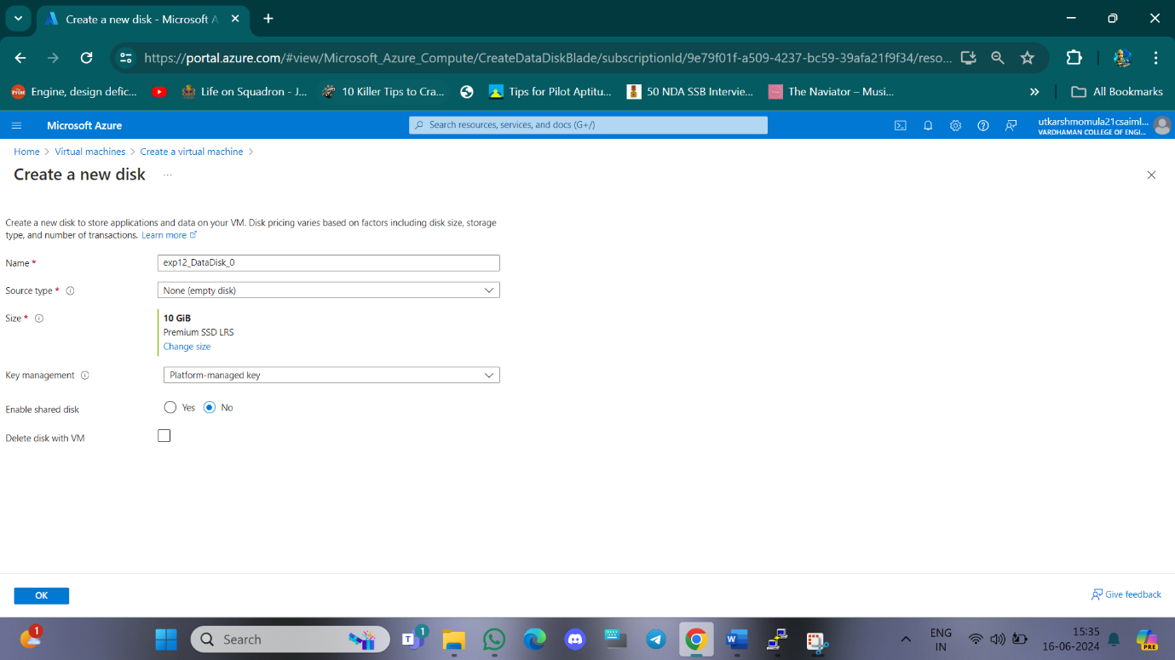

Step-5: Click on review+create and then create, go to resource group and copy Ip address and login to remote desktop connection with username and password.

Step-6: Click on Disks in left hand side to check the attached data disk to windows server.

Step-7: Click on detach symbol at right end of data disk and click apply to detach data disk from windows server.

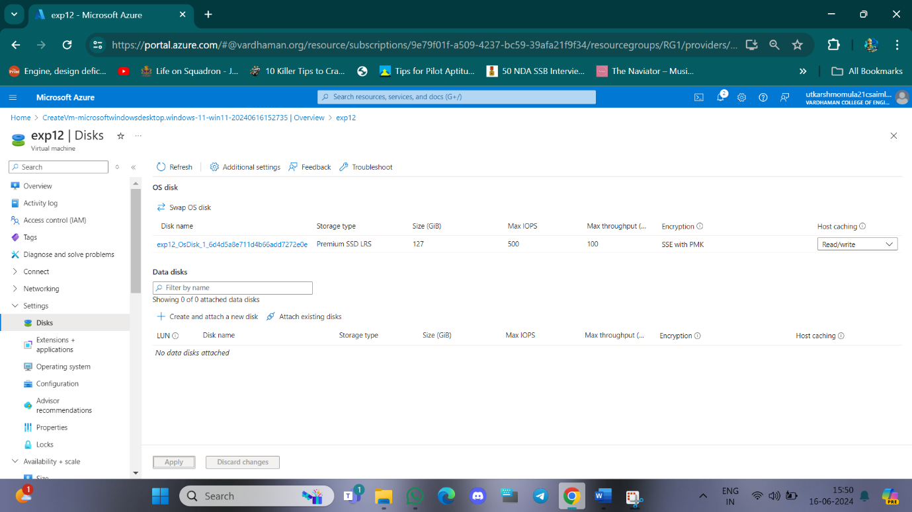

**Q13)How to attach and detach data disk to Linux server in azure?**

**Step-1: Create a Virtual Machine with ubuntu sever and username and password.**

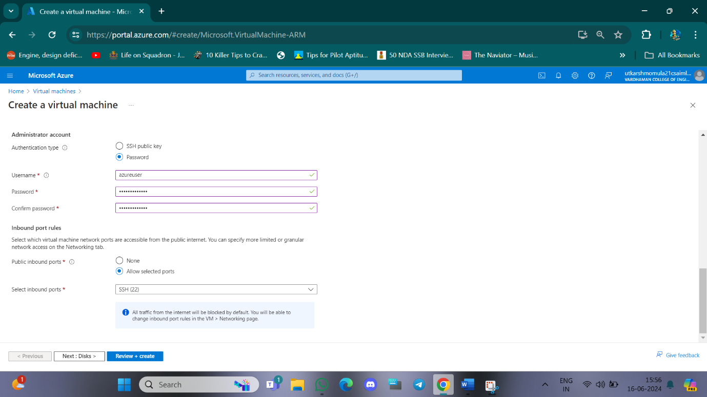

**Step-2: Click on Next: Disk and then select OS disk size-30GiB, Os disk type – Premium SSD(LRS) , enable “Delete with VM” and click on “Create and Attach a new data disk”.**

**Step-3: Change size to 5GiB and Select Delete disk with VM**

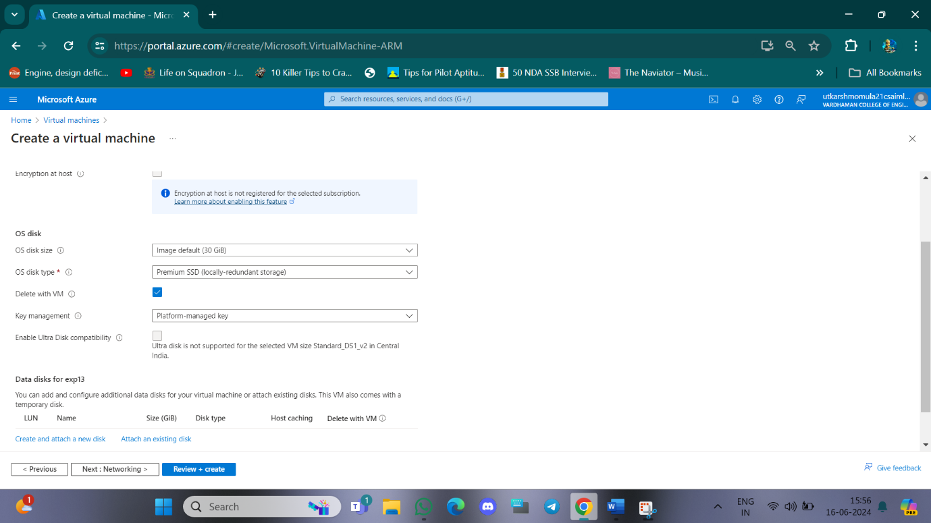

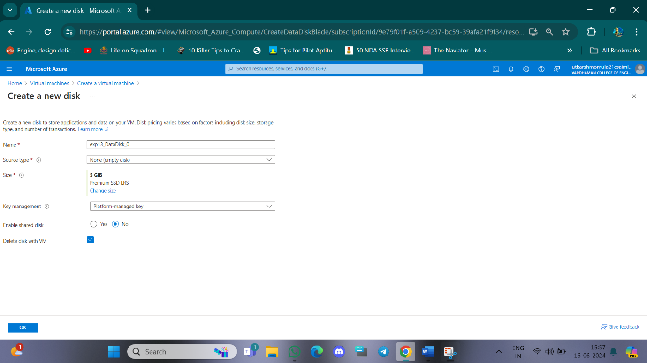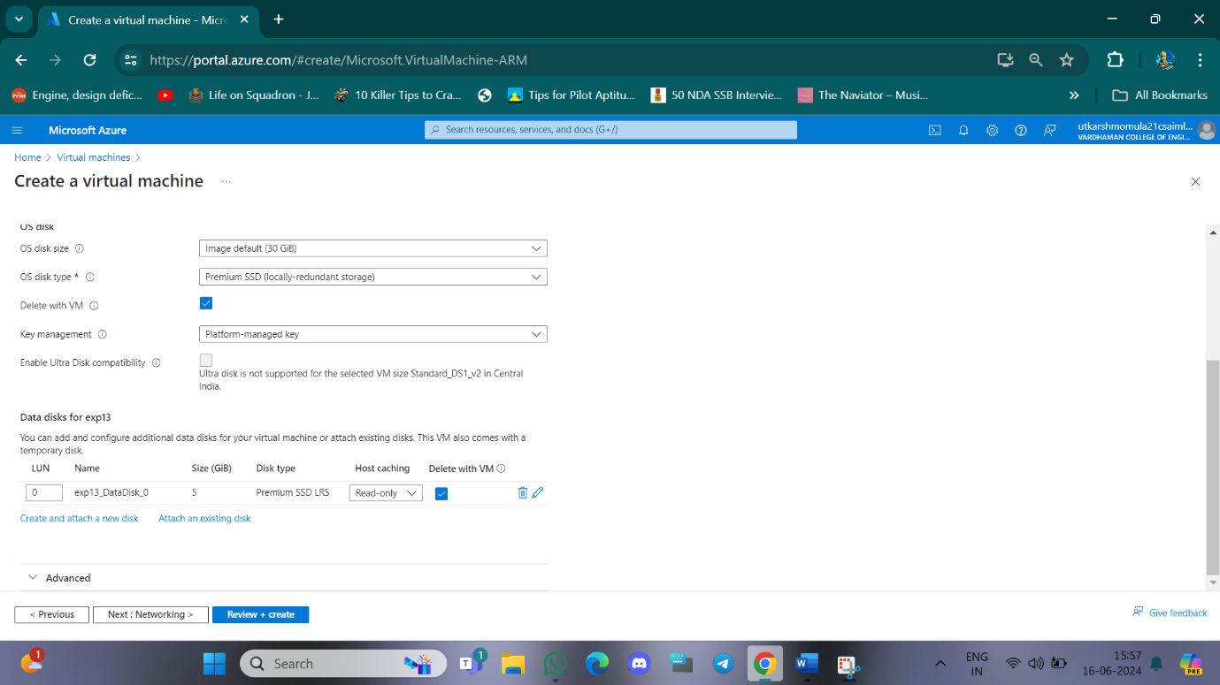

**Step-4: . Click OK and Review+Create then Create.**

**Step-5: Go to resource group and copy Ip address and then open “Putty” paste the Ip address and click Open.**

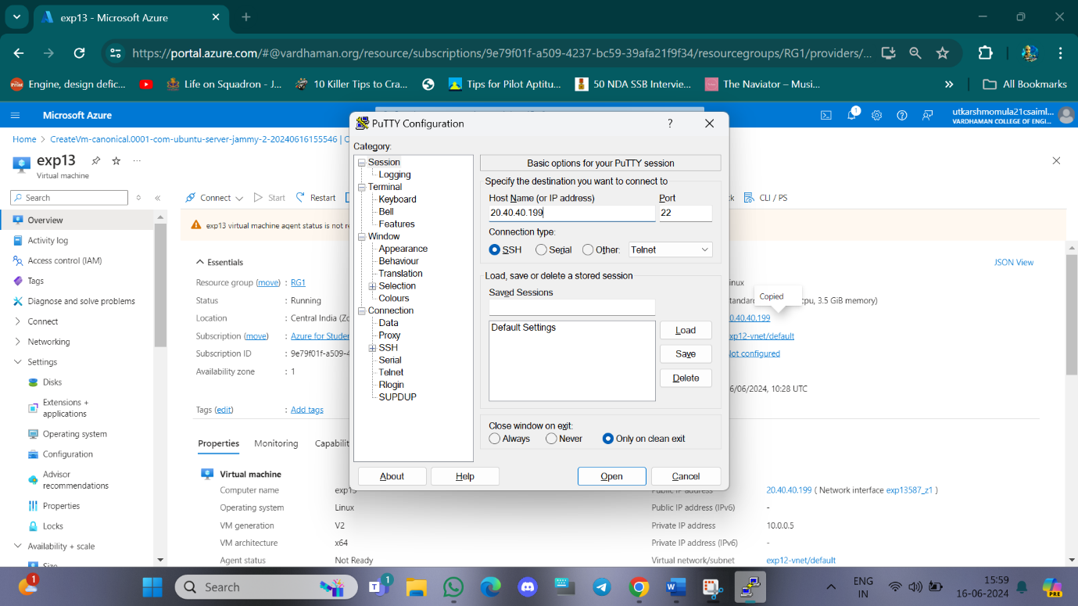

**Step-6: Login with username and password and type the commands:**

$ df -hT

$ lsblk

$ sudo filoe -s/dev/sdc

$ sudo mkfs -t ext4 /dev/sdc

$ mkdir test

$ sudo mount /dev/sdc/ test

$ cd test

$df -hT

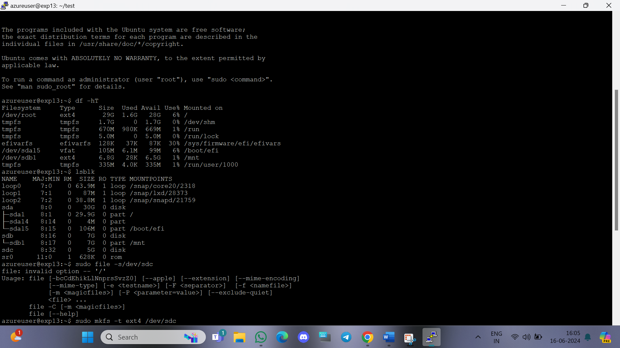

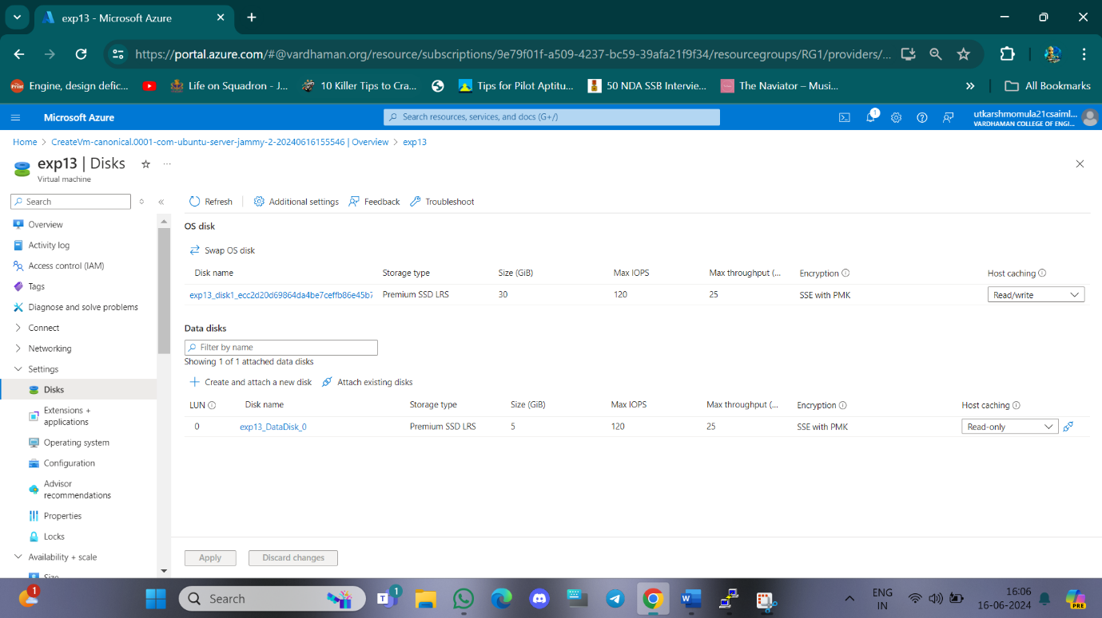

**Q14)Hosting of a static website in Azure**

Step-1: Create a Storage Account make sure to change redundancy as Locally Redundant storage and click review and click create.

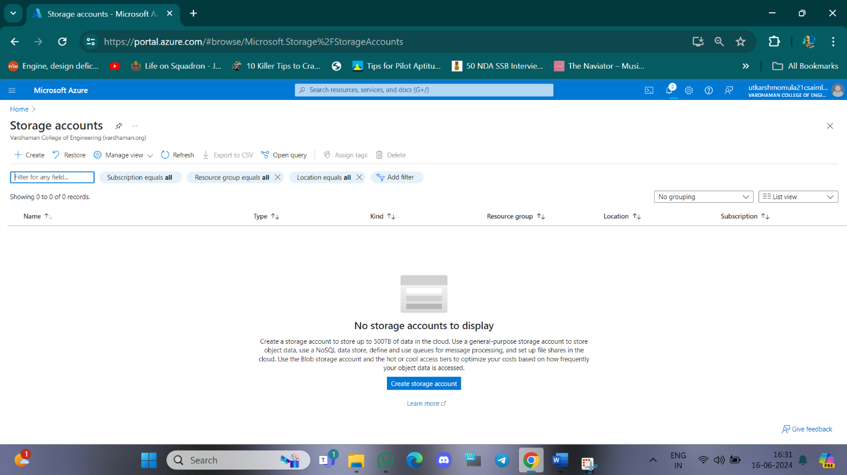

Step-2: After deployment od Storage Account click on go to resource then go to Static Website in left hand side.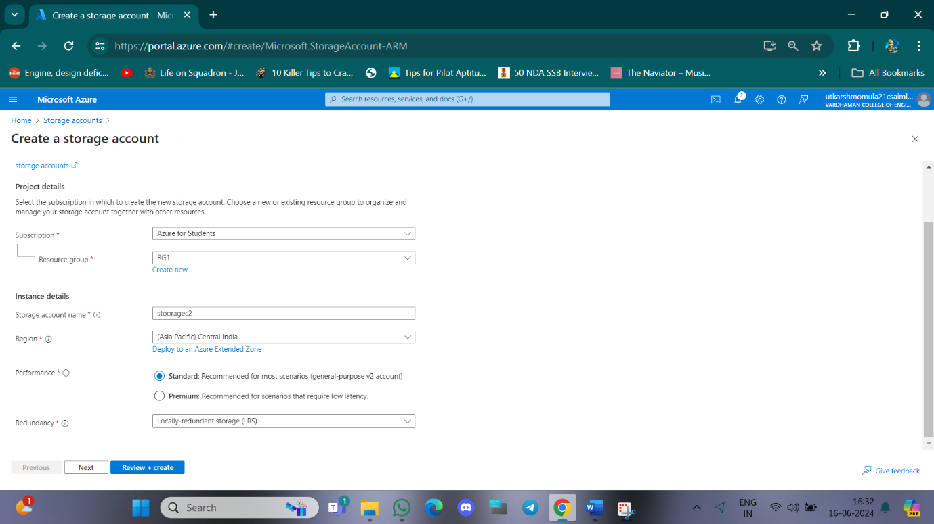

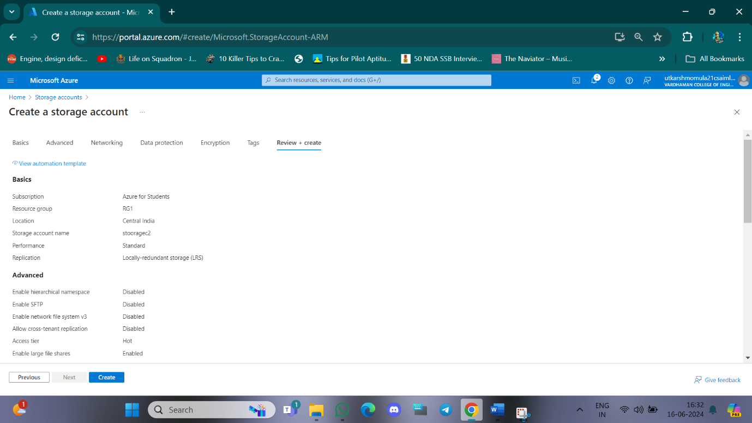

Step-3: Click on Enable under static website then fill index document and error document name and click save and copy the primary endpoint url.

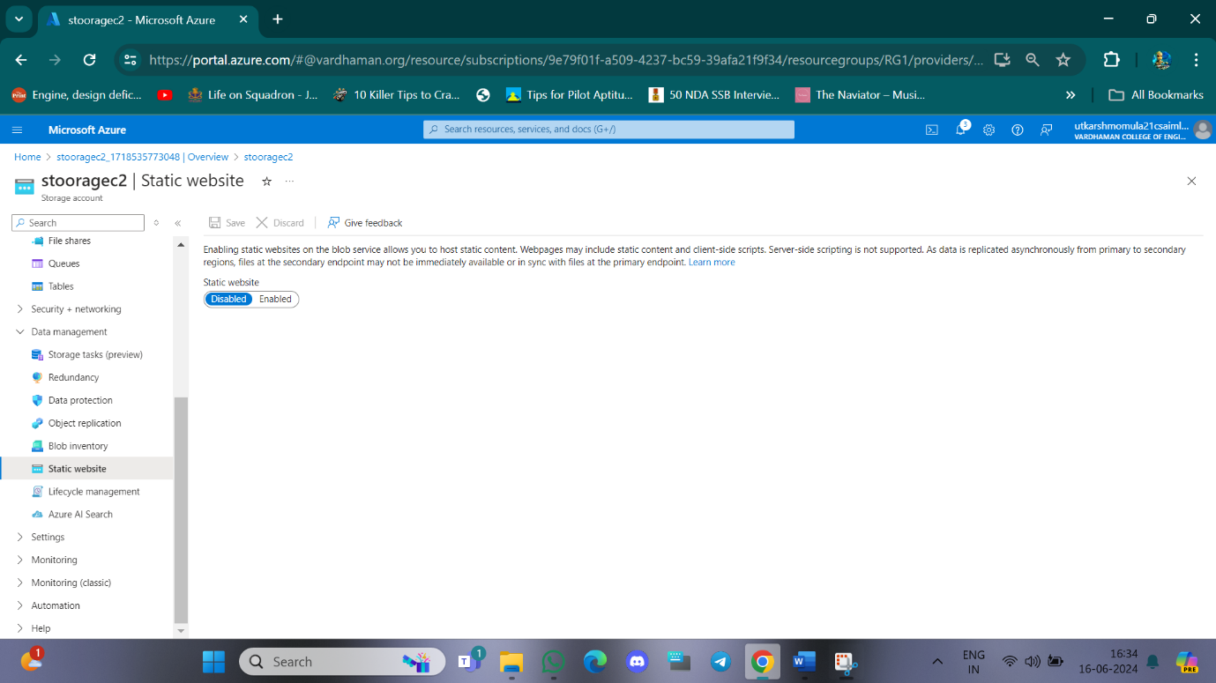

Step-4: Navigate to Containers on left hand side and open $web.

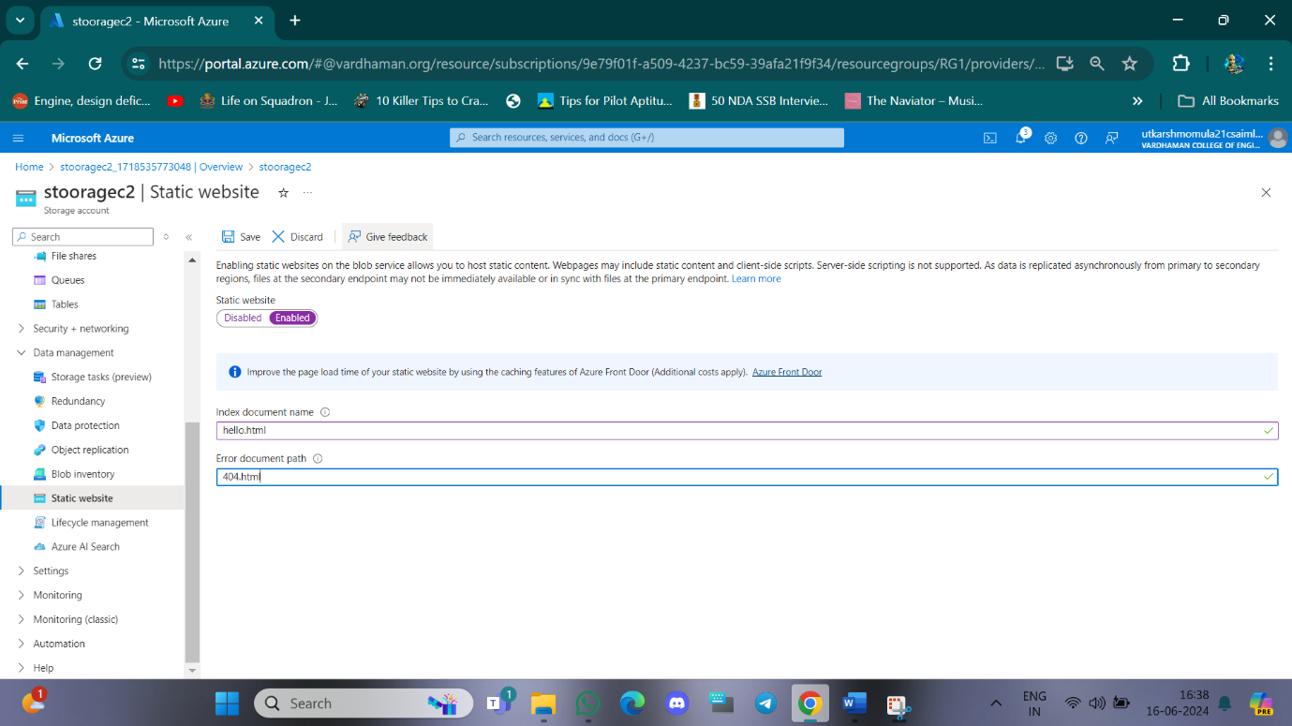

Step-5: Make a index.html file make sure to have the same name as given in static website. 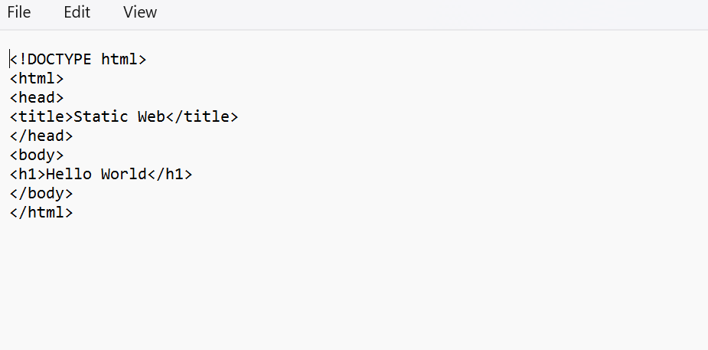

Step-6: Upload the file in web container by clicking on upload.

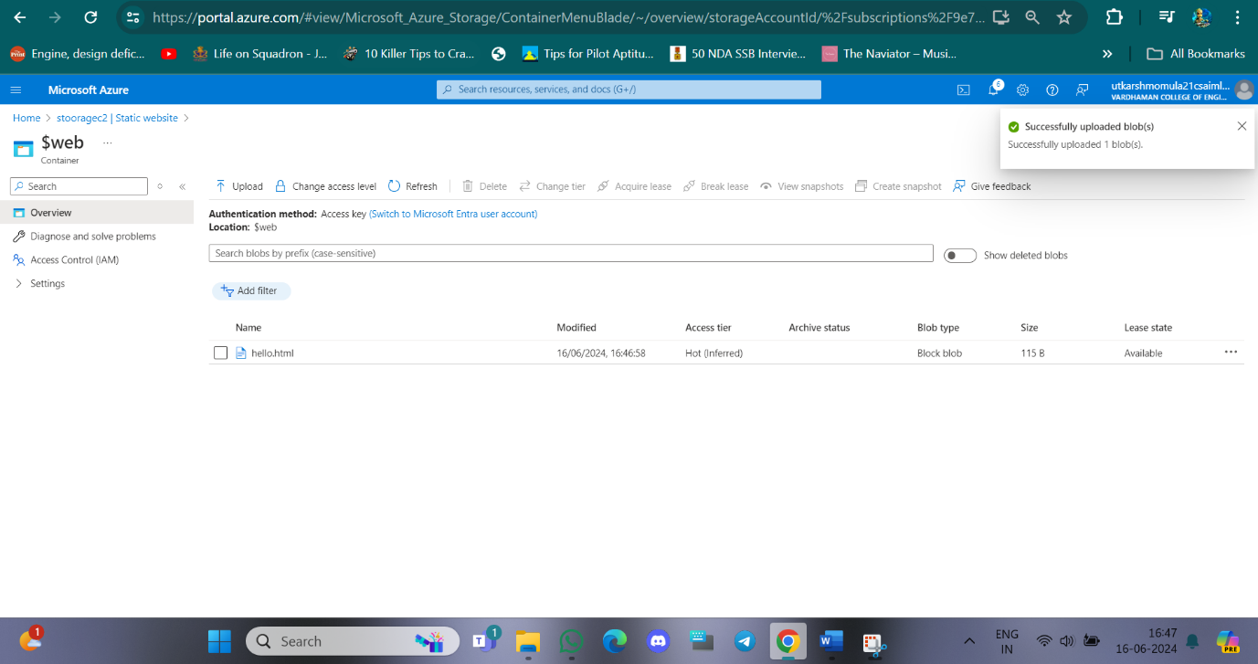

Step-7: Now paste the endpoint URL in new tab.

